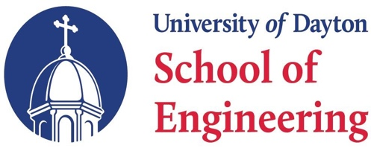

Review of Tenure-Track/Tenured Faculty Summary of Evidence Form

Name: Sidaard Gunasekaran
Department: Mechanical and Aerospace Engineering
Faculty Rank: Assistant Professor
Date of Hire: 15 Aug 2016
Date of Review: 30 June 2022
Type of Review: Tenure Review
Please attach your Professional Strategic Plan and CV to this form:
Instructions: For each of the elements that make up your Professional Strategic Plan, list the activities and evidence to support your self-evaluation of the level of accomplishment for that element. For the Annual Performance Review, highlight those activities and evidence from this calendar year. For application for tenure and/or promotion, please provide only the evidence since coming to the University of Dayton or since your last promotion (whichever comes last).
Table of Contents
Review of Tenure-Track/Tenured Faculty Summary of Evidence Form 1
Element 1: 2
Criteria 1: Demonstrated consistent effective mentoring of undergraduate or graduate students with dissemination of the research through publications, presentations, etc. 3
Criteria 2: Evidence of mentee accomplishments related to scholarship (e.g., the mentee receiving a regional award, scholarship, etc.) 9
Criteria 3: Some evidence of inclusive mentoring (e.g., engaging diverse students in their research, organizing seminars to cultivate broader participation in engineering research). 11
Element 2: 14
Criteria 1: Demonstrated record of peer-reviewed archival journal and conference publications as determined through agreed upon scholarship plan. 14
Element 3: 20
Criteria 1: Record of procuring funding and serving as PI or Co-PI on national, regional, or local grants, or industrial contracts with a record of proposal writing and submission to external agencies. 20
Element 4: 30
Criteria 1: Routinely employs effective techniques and strategies to create an inclusive learning environment. 30
Criteria 2: Consistently demonstrates highly effective teaching through self-reflection and peer evaluations of teaching in all classes. 33
Criteria 3: Employs a philosophy of continuous improvement by seeking feedback from students and peers. 34
Criteria 4: Routinely employs novel teaching techniques and best practices such as active and collaborative learning, community engaged learning and entrepreneurial minded learning in all courses taught. 36
Criteria 5: Routinely, develops and updates course materials. 38
Criteria 6: Incorporates some or all the five characteristics of a Marianist education. 38
Criteria 7: Provides guidance to other faculty within the University with respect to teaching effectiveness. 40
Element 5: 43
Criteria 1: Significant contribution to School and/or University level committee or multiple School or departmental committees 43
Element 6: 46
Criteria 1: Regularly participates in professional development sessions or participates in semester-or year long professional development opportunities associated with diversity, equity, and inclusion and/or intercultural competence 46
Criteria 2: Demonstrates effective use of inclusive practices in the classroom, when working with other faculty or staff, or in advising 46
Criteria 3: Makes significant contributions through active participation on a working group or task force aimed at addressing issues of equity and inclusion at the School level. 48
Elected Element 1: 51
Criteria 1: Development of several new courses and/or significant redesign of multiple courses that leads or supports the development of a new program. 51
Elected Element 2: 63
Criteria 1: Consistent implementation of project, problem, inquiry and entrepreneurial based learning activities. 63
Criteria 2: Effective mentoring of other faculty in these pedagogical practices 68
Criteria 3: Use of continuous improvement strategies for inset list 69
Criteria 4: Development of tools, resources, etc. to facilitate implementation (online content, handouts, grading rubrics, etc.) 69
Elected Element 3: 73
Criteria 1: Multi-year commitment as the formal adviser to a team or club that includes active engagement with the students, promotion of the team or club, and its students that may include travel to competitions or conferences 73
Criteria 2: Helping with fund raising 76
Criteria 3: Recognition through regional publications, awards, and honors. 77
Broader Impact Element: 80
Criteria 1: Sustained (participation for several semesters) participation in long-term service activities 80
Summative Comments: 87

Element 1: Mentoring and directing undergraduate, graduate and faculty research, scholarship and creative works, independent study courses (e.g. theses/dissertations, proposals, honors, etc.)
List of Activities or Evidence to support progress for this Element.

Criteria 1: Demonstrated consistent effective mentoring of undergraduate or graduate students with dissemination of the research through publications, presentations, etc.

I. Summer Undergraduate Research Experience (SURE) Student mentorship

1. Nathan Thomas., “Affecting Wingtip Vortex By Influencing Wing Surface Flow Direction”, Summer 2017
2. Summer Jenkins., “Sensitivity of Wing Surface Contours on Aerodynamic Efficiency”, Summer 2018
3. Grant Ross., “Performance of Inverted Flexible PVDF Membrane in the Wake of SD7003 Airfoil”, Summer 2018
4. Bryan Hoffman., “Characterizing the Power Generation of Spanwise Savonious-type Turbine”, Summer 2019

II. Graduate Student Summer Fellowship (GSSF) Student Mentorship

1. Jielong Cai
Cai, Jielong.,“Changes in Propeller Performance in Ground Proximity.” Summer 2019

2. Neal Novotny
Novotny, Neal., “Design and Characterization of a Wind Lens Turbine Grid Array.” Summer 2019

3. Jielong Cai
Cai, Jielong., “Propeller Ground and Partial Effect.” Summer 2020

4. Rachael Supina
Supina, Rachael.,“Gust Mitigation using Active Control of a Morphing Wing.” Summer 2021

5. Madison Peyton
Peyton, Madison., “Investigations into Wake Interactions of Wind Lenses at Close Proximities.” Summer 2021

III. Other Sponsored/Un-Sponsored Undergraduate Student Research Mentorship

1. Garry Pierre., “On the Design of Sting Mount for Force Based Experiments and Surface Flow Visualization in an Open Jet Wind Tunnel”, Sponsored by French Airforce, Fall 2016.

2. Tim Gerham., “Effect of Chordwise Slots on Aerodynamic Efficiency and Wingtip Vortex”, Fall 2016 – Spring 2017.

3. Daniel Curry., “Effect of Segmented Trailing Edge Extensions of Aerodynamic Efficiency”, Spring 2017 – Fall 2017.

4. Asa Palmer., “Curved Boundary Layer Fences and its Effect on Wingtip Vortex and Aerodynamic Efficiency”, Sponsored by Ohio Space Grant Consortium (OSGC), Fall 2017 – Spring 2019.
5. Joe Ivarson, and Lars Maneck., “Deep Learning Algorithm for Atomization Characterization using Shadowgraph Images: A Novel Approach for Spray Drift Analysis”, Sponsored by STEM Catalyst, Fall 2020 – Summer 2021.

6. George Gogidze, “Propeller and Propeller-In-Wing Thrust Vectoring”, Fall 2021 – Present.

IV. Undergraduate Honors Thesis Mentorship (Clare-Booth Luce Fellowship)

1. Faith Loughnane
Loughnane, Faith A., "Effect of Airfoil-Preserved Undulations on Wing Performance and Wingtip Vortex" (2020). Honors Theses. 300. https://ecommons.udayton.edu/uhp_theses/300

2. Grace Culpepper
Culpepper, Grace G., "Propeller and Propeller-In-Wing Thrust Vectoring" (2021). Honors Theses. 311. https://ecommons.udayton.edu/uhp_theses/311

V. Master’s Thesis Mentorship

Completed Thesis
1. Steve Goodman (Primary)
Goodman, Steven. "Correlations Between Near Wake Velocity Fluctuations and Aerodynamic Efficiency for the SD7003 Airfoil." Master's thesis, University of Dayton, 2018. http://rave.ohiolink.edu/etdc/view?acc_num=dayton1524137507116155

2. Brock Pleiman (Committee member)
Pleiman, Brock. "Calibration of a Flow Angularity Probe with a Real-Time Pressure Sensor." Master's thesis, University of Dayton, 2019. http://rave.ohiolink.edu/etdc/view?acc_num=dayton1568119292467936

3. Paul Sholtis (Committee member)
Sholtis, Paul. “Characterization of Upstream Effects Due to High Blockage in the AFRL Vertical Wind Tunnel”, Master’s Thesis, University of Dayton, 2019.
http://rave.ohiolink.edu/etdc/view?acc_num=dayton155594746187138
4. Jielong Cai (Primary)
Cai, Jielong. "Changes in Propeller Performance Due to Ground and Partial Ground Proximity." Master's thesis, University of Dayton, 2020. http://rave.ohiolink.edu/etdc/view?acc_num=dayton1588164898961792

5. Eric Insana (Primary)
Insana, Eric. "Low Reynolds Number Experimental Aerodynamic Verification of Scaled and LEWICE Simulated Ice Accretions in SLD Conditions." Master's thesis, University of Dayton, 2020. http://rave.ohiolink.edu/etdc/view?acc_num=dayton1597082782224451

6. Sam Barnhart (Primary)
Barnhart, Samuel. "Design and Development of a Coherent Detection Rayleigh Doppler Lidar System for Use as an Alternative Velocimetry Technique in Wind Tunnels." Master's thesis, University of Dayton, 2020. http://rave.ohiolink.edu/etdc/view?acc_num=dayton1595276402371536

7. Josh Deslich (Primary)
Deslich, Joshua. "Effects of a Bell-Shaped Lift Distribution on an Oblique Flying Wing and its Impact on Aerodynamic Performance." Master's thesis, University of Dayton, 2020. http://rave.ohiolink.edu/etdc/view?acc_num=dayton1590560243607956

8. Madeline Lickenbrock (Committee Member)
Lickenbrock, Madeline. "Multi-fidelity, Multidisciplinary Design Analysis and Optimization of the Efficient Supersonic Air Vehicle." Master's thesis, University of Dayton, 2020. http://rave.ohiolink.edu/etdc/view?acc_num=dayton1608156251624819

9. Ben Moidel (Committee Member)
Moidel, Benjamin. "Development and Validation of Single-Engine General Aviation Aircraft Models within Merlin 521 Motion-Based Flight Simulators." Master's thesis, University of Dayton, 2021. http://rave.ohiolink.edu/etdc/view?acc_num=dayton1619738645033377

10. Michael Mongin (Primary)
Mongin, Michael. “Closed Loop Control of Lift Coefficient at High Amplitudes and at Different Reduced Frequencies.” Master’s thesis, University of Dayton, 2021.
http://rave.ohiolink.edu/etdc/view?acc_num=dayton1639590733428631

ii. Ongoing Masters Thesis and Projects

1. Andrew Killian, “Investigation of Dynamic Reattachment on a Wing’s Large Amplitude Gust Response”
2. Ian Tierney, “Effect of Propeller Wake on Spray Drift from Agricultural Nozzles”
3. Nevin Jestus, “Aerodynamic Characterization of Wing-Wing Interactions in Distributed Lift Systems”
4. Luke Duncan, “Next Generation Luge with Advanced Aerodynamics and Performance Enhancements”
5. John Leonard, “On-Body Pressure Field Characterization of a Wing in Unsteady Flow using Pressure Sensitive Paint”

VI. Ph.D. Dissertation Mentorship

i. Completed Dissertation

1. Saad Qureshi (Committee Member)
Saad Qureshi, “Predicting Aerially Delivered Retardant Ground Deposit Concentrations and Spatial Distributions using Statistical and Algebraic Modeling with Influence from Experimental Techniques”, Ph.D. Dissertation, University of Dayton, 2022

ii. Ongoing Dissertation
1. Jielong Cai, "Changes in Propeller Performance Due to Close Proximity in Compact Configuration"
2. Molly Donovan, “Impact of Turbulence Intensity on Low Pressure Turbine Blades” (Committee Member)
3. Katie Opacich, “Investigation of Ignition Kernel to Kernel Interactions by Utilizing Imaging Diagnostics around/within a Small Flow Tunnel” (Committee Member)
4. Osama Alsattam, “On the Use of Event Camera for Fluid Flow Diagnostics Applications” (Committee Member)
5. Josh Deslich, ““Multi-Fidelity and Multi-Disciplinary Design Optimization of a Flying Wing” (Committee Member)

VII. Senior Design Team Mentorship

Spring 2017 – Abdulrahman Alanezi, Robert Alexander, Rosaana Lawandi, Joseph Passafiume, LION Apparel – Ingress Chamber (Advisor/Consultant)
Fall 2018 – Andrew Bogle, Kristi Hicks, Salman Kassim, David Kreinar, Mobile Slide Capturing (Sponsor)
Fall 2018 – Luke Hoover, Chris Negri, Devon Florczak, Yousiff Alkhalfan, Vertical Rotary Table for Wind Tunnel (Sponsor)
Spring 2019 – Patrick Doherty, Sam Franklin, Nate Borries, Abdullah Mugren, In-Flight Simulator Parameter Measuring Group (Advisor/Consultant)
Fall 2019 – Asa Palmer, Rachael Supina, Michael Mongin, Lindsey Weisman, Flow Control Swept Cylinder (Advisor/Consultant)
Fall 2019 – Greg Myak, Brandon Copenhaver, Hamad Bumaryoum, Design and Field Testing of Lensed Turbine Grid Array (Sponsor)
Spring 2021 – Jared Dunn, Nick Martin, Alex Myers, Aerodynamic Performance Improvements on USA Luge (Advisor/Consultant)

VIII. Independent Studies/Projects

1. Jacob Montgomery
Montgomery, Jacob. “Design and Development of a Flexible Wing using Additive Manufacturing.” Spring 2021

2. Madison Peyton
Peyton, Madison. “Investigations into Wake Interactions of Wind Lenses at Close Proximities.” Summer 2021

3. Ancy Johnson
Johnson, Ancy. “Effect of Unsteady Flow on Shedding Frequency of Slanted Cylinder”. Fall 2021

4. Andrew Killian
Killian, Andrew. “Advance Data Science and Machine Learning in Aerodynamics”. Summer 2022

4. Nevin Jestus
Jestus, Nevin. “Advance Data Science and Machine Learning in Aerodynamics”. Summer 2022

4. Ian Tierney
Tierney, Ian. “Advance Data Science and Machine Learning in Aerodynamics”. Summer 2022

IX. Research Publications with Students

All research publications with students are shown in Element 2 section

X. Research Presentations with Students (Since 2016)

Presentations at Local American Institute of Aeronautics and Astronautics (AIAA) Dayton-Cincinnati Science Symposium (DCASS)

1. Steven Goodman and Sidaard Gunasekaran, “Investigation of Near Wake Turbulent Fluctuations and its Relation to Wing Performance”, DCASS 2018, Sinclair Community College, Dayton.

2. Daniel Curry and Sidaard Gunasekaran, “Effect of Segmented Trailing Edge Extensions on Aerodynamic Efficiency”, DCASS 2018, Sinclair Community College, Dayton.

3. Nathan Thomas and Sidaard Gunasekaran, “Affecting the Wingtip Vortex by Influencing Wing Surface-Flow Direction”, DCASS 2018, Sinclair Community College, Dayton.

4. Thomas Cook and Sidaard Gunasekaran, “Characterization of Aerotech Shuttering System”, DCASS 2019, Sinclair Commuinty College, Dayton.

5. Jielong Cai and Sidaard Gunasekaran, “Changes in Propeller Performance Due to Ground Proximity”, DCASS 2019, Sinclair Community College, Dayton.

6. Faith Loughnane, Rachel Supina, and Sidaard Gunasekaran, “Wing Performance Changes Due to Wing Surface Contours”, DCASS 2019, Sinclair Community College, Dayton.

7. Josh Deslich and Sidaard Gunasekaran, “Effect of Slotted Winglet on the Wingtip Vortex”, DCASS 2019, Sinclair Community College, Dayton.

8. Neal Novotny, Jielong Cai, and Sidaard Gunasekaran, “Experimental Investigation of a Spanwise Axis Turbine in a Symmetric Wing”, DCASS 2019, Sinclair Community College, Dayton.

9. Samuel Barnhart and Sidaard Gunasekaran, “Investigation of Scaled Down Doppler LIDAR for Velocity Measurements in Wind Tunnels”, DCASS 2019, Sinclair Community College, Dayton.

10. Benjamin Moidel, Tim Reissman, Megan Reissman, Sidaard Gunasekaran, “Modeling and Validation of Pilot-Aircraft Cybernetic Systems”, DCASS 2020, Sinclair Community College, Dayton.

11. Samuel Barnhart and Sidaard Gunasekaran, “Investigation of Doppler LIDAR for Velocity Measurements in Wind Tunnels”, DCASS 2020, Sinclair Community College, Dayton.

12. Rachael Supina and Sidaard Gunasekaran, “Tailoring Lift Distribution Through Trailing Edge Extension Twist”, DCASS 2020, Sinclair Community College, Dayton.

13. Lucas Hung, Jielong Cai, Neal Novotny, and Sidaard Gunasekaran, “Development of a Multi-Purpose Flap and Spoiler Mechanism for High Endurance Unmanned Aerial Vehicles”, DCASS 2020, Sinclair Community College, Dayton.

14. Faith Loughnane, Michael Mongin, and Sidaard Gunasekaran, “Effect of Airfoil-Preserved Undulations on Wing Performance”, DCASS 2020, Sinclair Community College, Dayton.

15. Samuel Barnhart and Sidaard Gunasekaran, “Lift Coefficient Prediction of Distributed Blown Wings”, DCASS 2020, Sinclair Community College, Dayton.

16. Michael Mongin and Sidaard Gunasekaran, “Frequency Response of a Shuttered Open Jet Wind Tunnel”, DCASS 2020, Sinclair Community College, Dayton.

17. Rachel Sharp and Sidaard Gunasekaran, “Turbulent Near Wake Properties at Maximum Aerodynamic Efficiency Condition”, DCASS 2020, Sinclair Community College, Dayton.

18. Jielong Cai, Michael Ol, Anwar Ahmed, and Sidaard Gunasekaran, “Propeller Partial Ground Effect”, DCASS 2020, Sinclair Community College, Dayton.

19. Scott Chris, Matt Gazella, Jonathan Hill, Austin Abel, and Sidaard Gunasekaran, “Design and Analysis of an Additive Manufactured Supersonic Wind Tunnel”, DCASS 2020, Sinclair Community College, Dayton.

20. Jielong Cai, Michael Ol, and Sidaard Gunasekaran, “Changes in RC Propeller Performance under Various Mounting Pitch Angles”, DCASS 2021, Sinclair Community College, Dayton.

21. Grace Culpepper, Jielong Cai, and Sidaard Gunasekaran, “Propeller and Propeller-In-Wing Thrust Vectoring”, DCASS 2021, Sinclair Community College, Dayton.

22. Andrew Killian, Michael Mongin, Albert Medina, and Sidaard Gunasekaran, “Design and Characterization of Vortical Gust Generator in the University of Dayton Water Tunnel”, DCASS 2022, Sinclair Community College, Dayton.

23. Nevin Jestus and Sidaard Gunasekaran, “Wing-to-Wing Interactions on Distributed Lift Applications”, DCASS 2022, Sinclair Community College, Dayton.

24. Jielong Cai and Sidaard Gunasekaran, “Propeller Ground and Ceiling Effect in Forward Flight”, DCASS 2022, Sinclair Community College, Dayton.

25. Ian Tierney and Sidaard Gunasekaran, “Wake Effects on Agricultural Spray Using Drones”, DCASS 2022, Sinclair Community College, Dayton.

Presentations at Local American Society of Mechanical Engineers (ASME) Dayton-Engineering Student Science Symposium (DESS)

26. Steven Goodman and Sidaard Gunasekaran, “Investigations of Near Wake Turbulent Fluctuations and its Relation to Wing Performance”, DESS 2017, Wright State University, Dayton.

27. Neal Novotny and Sidaard Gunasekaran, “Design and Characterization of Wind Lens Grid Array”, DESS 2019, Wright State Univeristy, Dayton.

28. Rachael Supina, Michael Mongin, and Sidaard Gunasekaran, “Wing Performance Changes Due to Trailing Edge Extensions”, DESS 2019, Wright State University, Dayton.

29. Faith Loughnane, Rachael Supina, Michael Mongin, and Sidaard Gunasekaran, “Effect of Airfoil-Preserved Undulations on Wing Performance”, DESS 2019, Wright State University, Dayton.

30. Jielong Cai, and Sidaard Gunasekaran, “Propeller Partial Ground Effect”, DESS 2019, Wright State University, Dayton.

31. Scott Chris, Matt Gazella, Jonathan Hill, Austin Abel, and Sidaard Gunasekaran, “Design and Analysis of an Additive Manufactured Supersonic Wind Tunnel”, DESS 2019, Wright State University, Dayton.

32. Samuel Barnhart and Sidaard Gunasekaran, “Investigation of Scaled Down Doppler LIDAR for Velocity Measurements in Wind Tunnels”, DESS 2019, Wright State University, Dayton.

33. Neal Novotny and Sidaard Gunasekaran, “Performance and Proximity Investigations on Small Scale Lensed Turbines”, DESS 2019, Wright State University, Dayton.

Presentations at the AIAA International Annual SCITECH Conference

All the peer-reviewed conference papers mentioned in Element 2 Section is accompanied by a 30 min presentation by the students.

Criteria 2: Evidence of mentee accomplishments related to scholarship (e.g., the mentee receiving a regional award, scholarship, etc.)

I. Proposals Written For/With Students

i. Funded:
1. Asa Palmer., “Curved Boundary Layer Fences and its Effect on Wingtip Vortex and Aerodynamic Efficiency”, Ohio Space Grant Consortium (OSGC), Spring 2018. $3,500
2. Loughnane, Faith A., "Effect of Airfoil-Preserved Undulations on Wing Performance and Wingtip Vortex", Clare Booth Luce Fellowship, 2018, $25,000
3. Samuel Barnhart, “Enhanced Optical Flow Diagnostics/Minimization of Particle Seeding”, Dayton Area Graduate Student Institute (DAGSI/AFRL), 08/15/2018 – 08/14/2019, $63,831.
4. Cai, Jielong,“Changes in Propeller Performance in Ground Proximity.”, Graduate Student Summer Fellowship, Summer 2019, $5,000
6. Novotny, Neal., “Design and Characterization of a Wind Lens Turbine Grid Array.”, Graduate Student Summer Fellowship, Summer 2019, $5,000
7. Loughnane, Faith A., "Effect of Airfoil-Preserved Undulations on Wing Performance and Wingtip Vortex", Sponsored by Ohio Space Grant Consortium (OSGC), Spring 2019, $3,500
8. Culpepper, Grace G., "Propeller and Propeller-In-Wing Thrust Vectoring", Clare Booth Luce Fellowship, 2019, $25,000
9. Cai, Jielong., “Propeller Ground and Partial Effect.”, Graduate Student Summer Fellowship, Summer 2020, $5,000
10. Supina, Rachael.,“Gust Mitigation using Active Control of a Morphing Wing.”, Graduate Student Summer Fellowship, Summer 2021, $5,000
11. Peyton, Madison., “Investigations into Wake Interactions of Wind Lenses at Close Proximities.” Graduate Student Summer Fellowship, Summer 2021, $5,000
12. Andrew Killian, “Investigation of Dynamic Reattachment on a Wing’s Large Amplitude Gust Response”, Dayton Area Graduate Student Institute (DAGSI/AFRL), 08/15/2021 – 08/14/2022, $58,810.

ii. Not Funded:
1. Luke Duncan, “Project USA Luge: A Quest to Create the Next Generation Luge with Advanced Aerodynamics and Performance Enhancements”, RUMPKE, Fall 2021, $62,000
2. Ian Tierney, “Investigations into Minimizing Spray Drift for Sustainable Agricultural Spraying using Drones”, Hanley Sustainability Institute (HSI), Fall 2021, Funding for Master’s Program (~$60,000)

II. Student Awards
2018: Asa Palmer - DESS Best Presentation in Undergraduate Student Presentation Competition
2018: Daniel Curry - Dayton-Cincinnati Aerospace Sciences Symposium Best Presentation Award
2018: Asa Palmer - Ohio Space Grant Consortium Best STEM Poster Award
2019: Jielong Cai (Jacky) – Koehler International Student Award, Univeristy of Dayton
2019: Jielong Cai (Jacky) – Outstanding Graduate Scholarship Award, Univeristy of Dayton
2021: Jielong Cai (Jacky) – Outstanding Graduates in Mechanical Engineering, Shanghai Normal Univeristy
2022: Jielong Cai (Jacky) – Best Art in Science Competition, Dayton-Cincinnati Annual Student Symposium (DCASS), 2022

III. Product Development Mentorship with Leonardo Enterprises

Spring 2019 – Present: Breezy Technologies with Jielong Cai and Neal Novotny

Product 1: The lensed turbine grid array was designed, tested in the UD wind tunnel, and field tested. The product is designed to provide alternate energy generation method by installing small scale lenses in a grid. The aerodynamic investigations were conducted at University of Dayton Low Speed Wind Tunnel (UD-LSWT) to determine the appropriate spacings between two lenses that maximizes power output. Successful implementation of the grid lens array is shown in figure below.

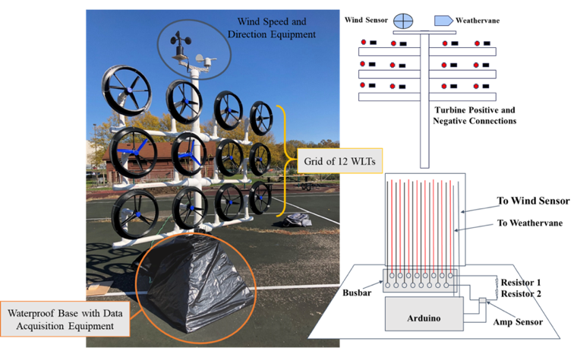
Figure 1.1 Lensed Turbine Grid Array Designed and Field Tested at University of Dayton

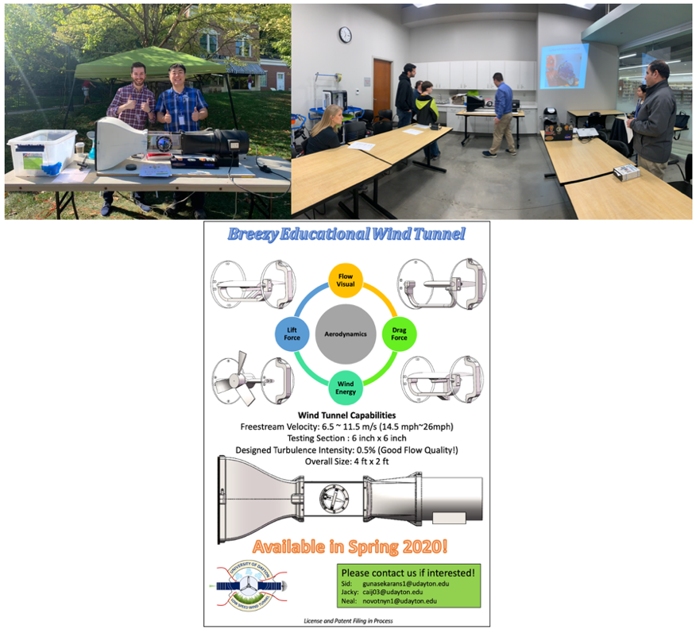
Figure 1.2 Demonstrating the small-scale wind tunnel to the general public at Caroline Park (left) and at Woodbourne Library, Far Hills, Dayton, OH (right)

Product 2: Breezy Educational Wind Tunnel
The Breezy educational wind tunnel provides an excellent platform for middle school and high school teachers and students to demonstrate and learn simple flight related concepts such as lift and drag through hands-on approach. Commercial desktop wind tunnels are extremely expensive for middle to high school students and teachers to purchase. The Breezy wind tunnel costs $500 and can be manufactured (mostly 3D printed) for $300. The capability of the small scale wind tunnel was demonstrated to the general public through events at Caroline Park, Dayton and at Woodbourne Library, Dayton as shown below in the figures.

Criteria 3: Some evidence of inclusive mentoring (e.g., engaging diverse students in their research, organizing seminars to cultivate broader participation in engineering research).

The field of aerospace engineering, except for astronaut core remains male dominant. Since 2016, I have been striving to have strong female participation in research. I have been actively trying to engage female students to get interested in the field of aerospace engineering and engage them in research. I also constantly seek funding opportunities for them. Below are all the female students from my research group that I have advised.

1. Summer Jenkins (Summer 2018 - SURE program)
2. Faith Loughnane (2018 – 2020 Honors Thesis – Clare Booth Luce Scholar)
3. Rachel Sharp (2019 - 2020 Graduate student – Independent study)
4. Grace Culpepper (2019 – 2021 Honors Thesis – Clare Booth Luce Scholar)
5. Madison Peyton (2020 – 2021 Graduate student – GSSF Awardee)
6. Alexa Roberts (2020 – 2021 Undergraduate student)
7. Ancy Johnson (Fall 2021 Graduate student – Independent study)
8. Rachael Supina (2018 – Present Graduate student – GSSF Awardee)

I have also co-mentored the following female students and serving on their thesis/dissertation committee –
1. Molly Donovan
2. Katie Opacich
3. Jen Colborn
4. Madeline Lickenbrock

I have also worked with the following international students:

1. Jielong Cai (Ph.D. student)
2. Ancy Johnson (Independent Study/Project)
3. Ali Sumbundu (Integrated Turbine-in-Wing research project)

I also worked with students on research who have been diagnosed with autism and dyslexia. The names of those students will be disclosed upon request.

Faculty Self-Evaluation:
Accomplished
Comments:
Since 2016, I have mentored and continue to mentor several students as thesis advisor and research advisor from undergraduate to Ph.D. levels. Over 35 students have done research in some capacity in the University of Dayton Low Speed Wind Tunnel and University of Dayton Water Tunnel combined. 11 out of 35 are female students whom I actively try to engage in aerospace related research to promote inclusivity. My research group continues to grow and sustain students from undergraduate to Ph.D. level actively engaging in both fundamental and applied research. I have also been working with students in writing proposals to acquire funding from both internal and external sources. For these reasons, my self-evaluation is that I have accomplished in mentoring and directing students.
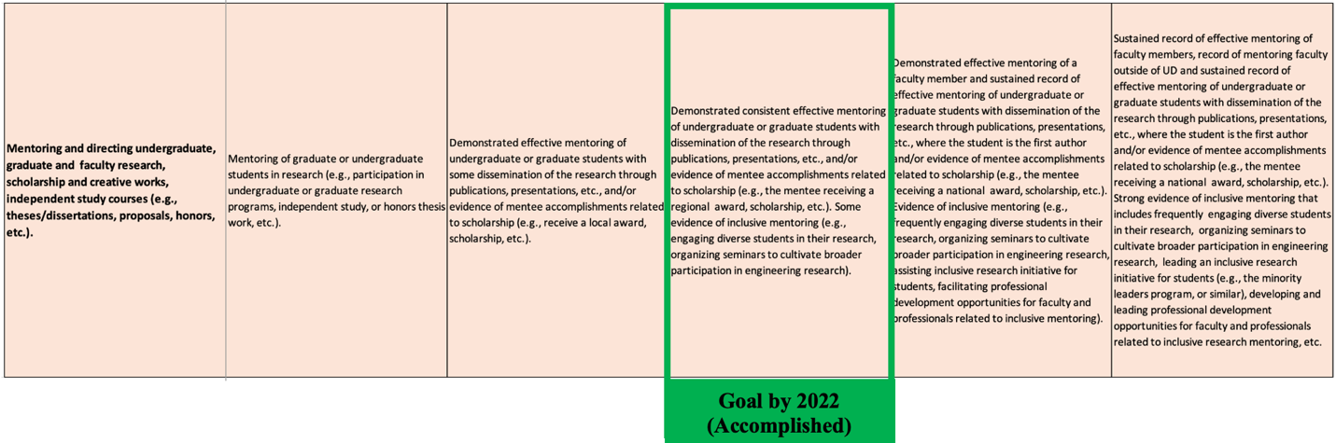

Department Faculty Development Committee Assessment (To be completed ONLY when the faculty member is going up for midterm or tenure and/or promotion review)
Choose an item.
Comments (optional): Click or tap here to enter text.

Department Chair Assessment:
Choose an item.
Comments (optional): Click or tap here to enter text.

School of Engineering Faculty Development Committee (To be completed ONLY when the faculty member is going up for midterm or tenure and/or promotion review)
Choose an item.
Comments (optional): Click or tap here to enter text.

Associate Dean for Faculty and Staff Development:
Choose an item.
Comments (optional): Click or tap here to enter text.

Element 2: Publications in refereed journals and peer-reviewed conference proceedings including technical, scientific, teaching/learning, pedagogy and other journals and conferences determined to be appropriate by the department
List of Activities or Evidence to support progress for this Element.

Criteria 1: Demonstrated record of peer-reviewed archival journal and conference publications as determined through agreed upon scholarship plan.

A. Magazine Articles

1. Gunasekaran, Sidaard and Doug Melton. “Getting EML Off the Ground: Why Do Jets Fly So High?”. KEEN Magazine, p 08. 2017 (https://engineeringunleashed.com/keenzine5/10/)

B. Peer-Review Journal Articles (since 2016)

Published:
1. Gunasekaran, Sidaard, and Daniel Curry. "On the Wake Properties of Segmented Trailing Edge Extensions." Aerospace 5, no. 3 (2018): 89. https://doi.org/10.3390/aerospace5030089

2. Gunasekaran, Sidaard, and Tim Gerham. "Effect of Chordwise Slots on Aerodynamic Efficiency and Wingtip Vortex." AIAA Journal 56, no. 12 (2018): 4752-4767. https://doi.org/10.2514/1.J057073

3. Gunasekaran, Sidaard, and Grant Ross. "Effect of Piezo-Embedded Inverted Flag in Free Shear Layer Wake." Aerospace 6, no. 3 (2019): 33. https://doi.org/10.3390/aerospace6030033

4. Cai, Jielong, Sidaard Gunasekaran, Michael OL, and Anwar Ahmed. "Propeller Ground and Ceiling Effect Parametric Data." Journal of Aircraft (2020): 1-4. https://doi.org/10.2514/1.C035839

5. Loughnane, Faith, Michael Mongin, Sidaard Gunasekaran, “Effect of Airfoil-Preserved Undulation Placement on Wing Performance and Wingtip Vortex”, AIAA Journal (2021) https://doi.org/10.2514/1.J059517

6. Gunasekaran, Sidaard, and Aaron Altman. "Far Wake and Its Relation to Aerodynamic Efficiency." Energies 14, no. 12 (2021): 3641. https://doi.org/10.3390/en14123641

7. Gunasekaran, Sidaard, Madison Peyton, and Neal Novotny. 2022. "Aerodynamic Interactions of Wind Lenses at Close Proximities" Energies 15, no. 13: 4622. https://doi.org/10.3390/en15134622
8. Cai, Jielong, Sidaard Gunasekaran, and Michael Ol. "Effect of Partial Ground and Partial Ceiling on Propeller Performance." Journal of Aircraft (2022): 1-14. https://doi.org/10.2514/1.C036974

C. Peer-Reviewed Conference Articles (since 2016)

1. Gunasekaran, Sidaard, and Aaron Altman. "Better Insight into the Wingtip Vortex-Free Shear Layer Interaction." 55th AIAA Aerospace Sciences Meeting, AIAA 2017-1705. https://doi.org/10.2514/6.2017-1705

2. Gunasekaran, Sidaard, and Aaron Altman. "Insight into Wingtip Vortex-Wing Free Shear Layer Interaction."10th International Symposium on Turbulence and Shear Flow Phenomenon (TSFP10), 2017.

3. Gunasekaran, Sidaard, and Tim Gerham. "Effect of Chordwise Slots on Aerodynamic Efficiency." 2018 AIAA Aerospace Sciences Meeting, p. AIAA 2018-0342. https://doi.org/10.2514/6.2018-0342

4. Gunasekaran, Sidaard and Daniel Curry. "Effect of Segmented Trailing Edge Extensions on Aerodynamic Efficiency." 2018 AIAA Aerospace Sciences Meeting, AIAA 2018-0343. https://doi.org/10.2514/6.2018-0343

5. Gunasekaran, Sidaard and Nathan Thomas. "Affecting Aerodynamic Efficiency by Influencing Wing Surface-Flow Direction." 2018 AIAA Aerospace Sciences Meeting, AIAA 2018-0344. https://doi.org/10.2514/6.2018-0344

6. Gunasekaran, Sidaard, Grant V. Ross, and Daniel Curry. "Effect of Flexible Inverted PVDF in Free Shear Layer Wake." In AIAA Scitech 2019 Forum, p. 1338. 2019. https://doi.org/10.2514/6.2019-1338

7. Goodman, Steven, Sidaard Gunasekaran, Aaron Altman, and Albert Medina. "On the Near Wake Turbulent Flow Properties of the SD7003 Airfoil." In AIAA Scitech 2019 Forum, p. 0073. 2019. https://doi.org/10.2514/6.2019-0073

8. Palmer, Asa E., and Sidaard Gunasekaran. "Effect of Curved Boundary Layer Fences on Aerodynamic Efficiency." In AIAA Scitech 2019 Forum, p. 1614. 2019. https://doi.org/10.2514/6.2019-1614

9. Cai, Jielong, Sidaard Gunasekaran, Anwar Ahmed, and Michael V. Ol. "Changes In Propeller Performance Due to Ground Proximity." In AIAA Scitech 2019 Forum, p. 1097. 2019. https://doi.org/10.2514/6.2019-1097

10. Deslich, Joshua, and Sidaard Gunasekaran. "Effect of Slotted Winglet on the Wingtip Vortex." In AIAA Aviation 2019 Forum, p. 3431. 2019. https://doi.org/10.2514/6.2019-3431

11. Loughnane, Faith A., Rachael Supina, Michael P. Mongin, and Sidaard Gunasekaran. "Effect of Airfoil-Preserved Undulations on Wing Performance." In AIAA Scitech 2020 Forum, p. 1784. 2020. https://doi.org/10.2514/6.2020-1784

12. Cook, Thomas, Sidaard Gunasekaran, Michael V. Ol, and Michael P. Mongin. "Frequency Response of a Shuttered Open Jet Wind Tunnel." In AIAA Scitech 2020 Forum, p. 1760. 2020. https://doi.org/10.2514/6.2020-1760

13. Novotny, Neal, and Sidaard Gunasekaran. "Performance and Proximity Investigations on Small Scale Lensed Turbines." In AIAA Scitech 2020 Forum, p. 1242. 2020. https://doi.org/10.2514/6.2020-1242

14. Barnhart, Samuel A., and Sidaard Gunasekaran. "Investigation of Doppler Lidar for Velocity Measurements in Wind Tunnels." In AIAA Scitech 2020 Forum, p. 1021. 2020. https://doi.org/10.2514/6.2020-1021

15. Gazella, Matthew R., Jonathon Hill, Scott Chriss, Austin J. Abel, and Sidaard Gunasekaran. "Design and Analysis of an Additive Manufactured Supersonic Wind Tunnel." In AIAA Scitech 2020 Forum, p. 1354. 2020. https://doi.org/10.2514/6.2020-1354

16. Deslich, Josh, Sidaard Gunasekaran, Peter Flick, and Douglas Szczublewski. "Effects of spanloading and slew angle on an Oblique Flying Wing." In AIAA Scitech 2020 Forum, p. 0532. 2020. https://doi.org/10.2514/6.2020-0532

17. Cai, Jielong, Sidaard Gunasekaran, Anwar Ahmed, and Michael V. Ol. "Propeller Partial Ground Effect." In AIAA Scitech 2020 Forum, p. 1028. 2020. https://doi.org/10.2514/6.2020-1028

18. Mongin, Michael P., and Sidaard Gunasekaran. "Lift Regulation Using Closed-Loop Feedback and Control." In AIAA Scitech 2021 Forum, p. 2000. 2021. https://doi.org/10.2514/6.2021-2000

19. Culpepper, Grace G., Jielong Cai, and Sidaard Gunasekaran. "Propeller and Propeller-in-Wing Thrust Vectoring." In AIAA Scitech 2021 Forum, p. 0615. 2021. https://doi.org/10.2514/6.2021-0615

20. Cai, Jielong, Sidaard Gunasekaran, and Michael V. Ol. "Propeller Partial Ground and Ceiling Effect Prediction." In AIAA Scitech 2021 Forum, p. 0614. 2021. https://doi.org/10.2514/6.2021-0614

21. Sarnhart, Samuel A., Barath Narayanan, and Sidaard Gunasekaran. "Blown Wing Aerodynamic Coefficient Predictions Using Traditional Machine Learning and Data Science Approaches." In AIAA Scitech 2021 Forum, p. 0616. 2021. https://doi.org/10.2514/6.2021-0616

22. Gunasekaran, Sidaard, and Rachel Sharp. "Airfoil Near Wake Turbulent Properties at Maximum Aerodynamic Efficiency Condition." In AIAA Scitech 2021 Forum, p. 1848. 2021. https://doi.org/10.2514/6.2021-1848

23. Loughnane, Faith A., Michael P. Mongin, and Sidaard Gunasekaran. "Effect of Airfoil-Preserved Undulations on Free Shear Layer." In AIAA Scitech 2021 Forum, p. 0847. 2021. https://doi.org/10.2514/6.2021-0847

24. B. N. Narayanan, Joseph Ivarson, Lars Maneck, Sidaard Gunasekaran , “Deep Learning Algorithm for Atomization Characterization using Shadowgraph Images”, 2021 IEEE National Aerospace and Electronics Conference (NAECON), Dayton, OH, USA, 2021.

25. Ivarson, Joseph T., Lars Maneck, Barath Narayanan Narayanan, and Sidaard Gunasekaran. "Deep Learning Algorithm for Atomization Characterization using Shadowgraph Images." In AIAA SCITECH 2022 Forum, p. 0188. 2022. https://doi.org/10.2514/6.2022-0188

26. Donovan, Molly H., Markus P. Rumpfkeil, Sidaard Gunasekaran, and Christopher R. Marks. "Analysis of High-lift Low Pressure Turbine Endwall Vortices Using Modal Decomposition Methods." In AIAA SCITECH 2022 Forum, p. 0477. 2022. https://doi.org/10.2514/6.2022-0477

27. Cai, Jielong, Sidaard Gunasekaran, and Michael V. Ol. "Sinusoidal Gust Response of RC Propellers at Different Incidence Angles." In AIAA SCITECH 2022 Forum, p. 1536. 2022. https://doi.org/10.2514/6.2022-1536

28. Peyton, Madison N., and Sidaard Gunasekaran. "Investigation into Wake Interactions of Wind Lenses at Close Proximities." In AIAA SCITECH 2022 Forum, p. 1789. 2022. https://doi.org/10.2514/6.2022-1789

29. Culpepper, Grace G., Jielong Cai, and Sidaard Gunasekaran. "Effect of Forward Propeller Tilt and Inlet Shape in Propeller-in-Wing Thrust Vectoring." In AIAA SCITECH 2022 Forum, p. 1539. 2022. https://doi.org/10.2514/6.2022-1539

30. Hung, Lucas K., Jielong Cai, Neal Novotny, and Sidaard Gunasekaran. "Development of a Multi-Purpose Flap and Spoiler Mechanism for High Endurance Unmanned Aerial Vehicles." In AIAA SCITECH 2022 Forum, p. 1027. 2022. https://doi.org/10.2514/6.2022-1027

31. Insana, Eric, and Sidaard Gunasekaran. "Low Reynolds Number Experimental Aerodynamic Verification of Scaled and LEWICE Simulated Ice Accretions in SLD Conditions." In AIAA SCITECH 2022 Forum, p. 2025. 2022. https://doi.org/10.2514/6.2022-2025

32. Mongin, Michael P., Sidaard Gunasekaran, Albert Medina, Raul Ordonez, and Andrew Killian. "High Amplitude Lift Tracking Using Closed-Loop Feedback and Control." In AIAA SCITECH 2022 Forum, p. 0046. 2022. https://doi.org/10.2514/6.2022-0046

D. Peer Reviewed Conference Articles Related to Teaching (since 2016)

1. Gunasekaran, Sidaard. "Integrated Teaching Model in Graduate Aerospace Classes: A Trial With Compressible Flow Aerodynamics." ASEE Annual Conference and Exposition. 2017. https://doi.org/10.18260/1-2--28546

2. Gunasekaran, Sidaard. "Integrated Teaching Model: A Follow Up with Fundamental Aerodynamics." ASEE Annual Conference and Exposition. 2018. https://peer.asee.org/30677

3. Gunasekaran, Sidaard. "Using Ideation, Disruption, Aha (IDA) Pedagogy in Introduction to Flight." ASEE Annual Conference and Exposition. 2019. https://peer.asee.org/25203

E. Citations
For Complete List of Published Work in MyBibliography, please see this link - https://goo.gl/sxdfbT
My citations continues to grow with an accelerated pace since 2017.
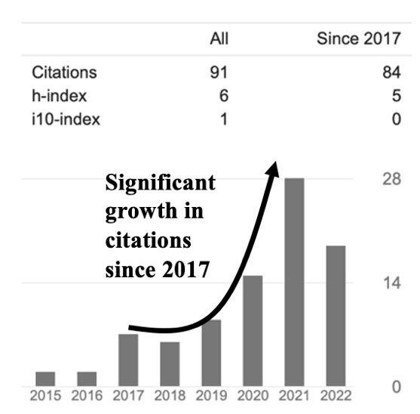

Faculty Self-Evaluation:
Accomplished
Comments:
Since 2016, I have published 7 journal papers, some of them in prestigious journals in aerospace such as the AIAA Journal and the Journal of Aircraft. I have published 32 peer-reviewed conference papers with over 25 undergraduate and graduate students combined on fundamental and applied research. Additionally, I have published three papers on novel teaching pedagogies and one national magazine article on my incorporation of entrepreneurially minded learning in my course. For these reasons, I self-evaluate myself as accomplished in publications.
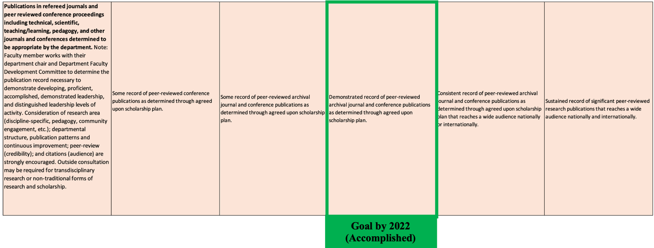
Department Faculty Development Committee Assessment (To be completed ONLY when the faculty member is going up for midterm or tenure and/or promotion review)
Choose an item.
Comments (optional):

Department Chair Assessment:
Choose an item.
Comments (optional):

School of Engineering Faculty Development Committee (To be completed ONLY when the faculty member is going up for midterm or tenure and/or promotion review)
Choose an item.
Comments (optional):

Associate Dean for Faculty and Staff Development:
Choose an item.
Comments (optional):

Element 3: Sponsored research (including traditional technical discipline specific research and research related to teaching, inclusive excellence, community-engaged learning, etc.), grants and contracts (including those from industry, the government and foundations)

List of Activities or Evidence to support progress for this Element.

Criteria 1: Record of procuring funding and serving as PI or Co-PI on national, regional, or local grants, or industrial contracts with a record of proposal writing and submission to external agencies.

I. Acquired External Funding:

A. From National/Regional/Local:

1. Equipment Grant for Custom Agricultural Spray Drift Test Section for University of Dayton Low Speed Wind Tunnel, Spray Analytics Incorporated, 08/15/2018, $25,000. Account Number: J942G0

2. Enhanced Optical Flow Diagnostics/Minimization of Particle Seeding, Dayton Area Graduate Student Institute (DAGSI/AFRL), 08/15/2018 – 08/14/2019, $63,831. Account Number: LXF000

3. Investigation of Dynamic Reattachment on a Wing’s Large Amplitude Gust Response, Dayton Area Graduate Student Institute (DAGSI/AFRL), 08/15/2021 – 08/14/2022, $58,810. Account Number: MKK000

4. Application of Traditional and Enhanced Machine Learning and Data Science for Active Flow Control Techniques, Defense Advanced Research Projects Agency (DARPA), Control of Revolutionary Aircraft with Novel Effectors (CRANE), UD Seedling Effort, 08/15/2021 – 05/15/2022, $70,000. Account Number: LFP192

B. From Industry:

5. Effect of Propeller Wake on Drift Potential of Agricultural Sprays, Badische Anilin and Soda Fabrik (BASF), 01/15/2022 – 08/15/2022, $50,000. Account Number: J942G0

6. Funding Acquired through Wind Tunnel Testing for Industries

A. Spray Analytics (Account Number: J942G0)

1. Dec 19th, 2018 - $812.50
2. Feb 12th, 2019 - $812.50
3. Aug 25th, 2020 - $1,200.00
4. Nov 6th, 2020 - $1,200.00
5. Nov 16th, 2021 - $3,000.00

B. Inteva Products (Account Number: J94330)

1. July 9th, 2021 - $1029.33
2. Oct 25th, 2021 - $789.153

II. Acquired Internal Funding:

1. Revision of Introduction to Flight Course, University of Dayton Hanley Sustainability Institute (HSI), 05/16/2017 – 08/15/2017, $2,500.

2. Affecting Drag of a Wing through Periodic Actuation of Smart Material in its Wake, Research Council Seed Grant (RCSG), 05/15/2017 – 08/15/2017, $5,000. Fund Number: 110003

3. Creativity Across the Curriculum Fellowship Cohort Program, University of Dayton Institute of Applied Creativity for Transformation, 08/15/2017 – 05/14/2018, $5,000.

4. Use of Trailing Edge Extensions for Enhanced Propeller Performance. University of Dayton Clare Boothe Luce Research Scholars Program, PI, Faith Loughnane (BS MEE student), 08/15/2018 – 05/15/2020, $25,200. Fund Number: 110003
5. Product Design and Development of Lensed Turbines, Leonardo Enterprises, 05/16/2019 – 08/15/2019, $10,000. Fund Number: 110003
6. Thrust vectoring characteristics of Wing Embedded Propeller. University of Dayton Clare Boothe Luce Research Scholars Program, PI, Grace Culpepper (BS MEE student), 08/15/2019 – 05/15/2021, $25,200. Fund Number: 110003
7. Deep Learning Algorithm for Atomization Characterization using Shadowgraph Images: A Novel Approach for Spray Drift Analysis, University of Dayton STEM Catalyst, Sidaard Gunasekaran (UD - PI), Barath Narayanan (UDRI - Co-PI), 05/16/2020 – 08/16/2021, $50,000. Fund Number: 100000
III. Funding Acquired from Kern Family Foundation:

1. Incorporating EML in Fundamental Aerodynamic Course. KEEN Cohort III, Part of UD’s institutional KEEN grant, 05/16/2017 – 08/15/2017, $13,500.

2. Review of EML Cards in EngineeringUnleashed.com. Community Catalyst Program, Kern Entrepreneurial Engineering Network, 01/15/2018 – 05/15/2018, $2,500

3. Review of EML Cards in EngineeringUnleashed.com. Community Catalyst Program, Kern Entrepreneurial Engineering Network, 08/15/2018 – 12/05/2018, $2,500

4. Design and Implementation of EML Modules in Aerospace Curriculum. Innovative Curriculum with Entrepreneurial Mindset (ICE) Workshop, Kern Family Foundation, 01/15/2018 – 08/15/2018, $2,000.

5. Review of EML Cards in EngineeringUnleashed.com. Community Catalyst Program, Kern Entrepreneurial Engineering Network, 01/15/2019 – 05/15/2019, $2,500

6. Review of EML Cards in EngineeringUnleashed.com. Community Catalyst Program, Kern Entrepreneurial Engineering Network, 08/15/2019 – 12/05/2019, $2,500

7. KEEN Summer Immersion Program, “Developing Course Modules for Aerodynamics with Industry Partnership”, KERN Family Foundation 5/15/2019 – 8/15/2019, $5,000.

8. Review of EML Cards in EngineeringUnleashed.com. Community Catalyst Program, Kern Entrepreneurial Engineering Network, 01/15/2020 – 05/15/2020, $2,500

9. KEEN Summer Immersion Program, “Developing Course Modules for Aerodynamics with Industry Partnership”, KERN Family Foundation 5/15/2020 – 8/15/2020 $5,000.

10. Creating EM-infused CourseDecks for Aerodynamics and Experimental Aerodynamics on Engineering Unleashed, Kern Family Foundation, 05/15/2021 – 08/15/2021, $10,000.

IV. Course Buyouts
1. “What is the University For?”, 2018 Faculty Seminar, University of Dayton. Course Buyout for Fall 2018. (Equivalent Cost: $10,250 (without benefits))

2. KEEN Faculty Ambassador, KERN Family Foundation. Course buyout for Spring 2019 (Equivalent Cost: $10,375 (without benefits))

3. KEEN Faculty Ambassador, KERN Family Foundation. Course buyout for Fall 2019 (Equivalent Cost: $10,375 (without benefits))

4. KEEN Faculty Ambassador, KERN Family Foundation. Course buyout for Spring 2020 (Equivalent Cost: $10,500 (without benefits))

V. Travel Funds
1. Funding Support for Students to Travel to SCITECH 2022 conference in SanDiego, Local Chapter (Dayton/Cincinnati) of American Institute of Aeronautics and Astronautics (AIAA), 12/05/2021, $500.

VI. Summary of Total Funds

Project/Source | Duration (to date) | Amount (to date)
External Support:
Custom Spray Test Section - Equipment Grant from Spray Analytics, Inc. | 08/15/2018 | $25,000
Enhanced Optical Flow Diagnostics/Minimization of Particle Seeding, Dayton Area Graduate Student Institute (DAGSI/AFRL) | 08/15/2018 – 08/14/2019 | $63,831
Massively Unsteady, Vortex Dominated Flows on Pitching and Plunging Wings, Dayton Area Graduate Student Institute (DAGSI/AFRL) | 08/15/2021 – 08/14/2022 | $58,810
Application of Traditional and Enhanced Machine Learning and Data Science for Active Flow Control Techniques, Defense Advanced Research Projects Agency (DARPA) | 08/15/2021 – 05/15/2022 | $70,000
Effect of Propeller Wake on Drift Potential of Agricultural Sprays, Badische Anilin and Soda Fabrik (BASF) | 01/15/2022 – 08/15/2022 | $50,000
 | TOTAL EXTERNAL FUNDS | $267,641
Internal Support:
Revision of Introduction to Flight Course, University of Dayton Hanley Sustainability Institute (HSI) | 05/16/2017 – 08/15/2017 | $2,500
Affecting Drag of a Wing through Periodic Actuation of Smart Material in its Wake, Research Council Seed Grant (RCSG) | 05/15/2017 – 08/15/2017 | $5,000
Creativity Across the Curriculum Fellowship Cohort Program, University of Dayton Institute of Applied Creativity for Transformation | 08/15/2017 – 05/14/2018 | $5,000
Use of Trailing Edge Extensions for Enhanced Propeller Performance. University of Dayton Clare Boothe Luce Research Scholars Program | 08/15/2018 – 05/15/2020 | $25,000
Product Design and Development of Lensed Turbines, Leonardo Enterprises | 05/16/2019 – 08/15/2019 | $10,000
Thrust vectoring characteristics of Wing Embedded Propeller. University of Dayton Clare Boothe Luce Research Scholars Program | 08/15/2019 – 05/15/2021 | $25,000
Deep Learning Algorithm for Atomization Characterization using Shadowgraph Images: A Novel Approach for Spray Drift Analysis, University of Dayton STEM Catalyst | 05/16/2020 – 08/16/2021 | $50,000
 | TOTAL INTERNAL FUNDS | $122,500
KEEN Funding:
Incorporating EML in Fundamental Aerodynamic Course. KEEN Cohort III | 05/16/2017 – 08/15/2017 | $13,500
Review of EML Cards in EngineeringUnleashed.com. Community Catalyst Program, Kern Entrepreneurial Engineering Network | 01/15/2018 – 05/15/2018 | $2,500
Review of EML Cards in EngineeringUnleashed.com. Community Catalyst Program, Kern Entrepreneurial Engineering Network | 08/15/2018 – 12/05/2018 | $2,500
Design and Implementation of EML Modules in Aerospace Curriculum. Innovative Curriculum with Entrepreneurial Mindset (ICE) Workshop | 01/15/2018 – 08/15/2018 | $2,000
Review of EML Cards in EngineeringUnleashed.com. Community Catalyst Program, Kern Entrepreneurial Engineering Network | 01/15/2019 – 05/15/2019 | $2,500
Review of EML Cards in EngineeringUnleashed.com. Community Catalyst Program, Kern Entrepreneurial Engineering Network | 08/15/2019 – 12/05/2019 | $2,500
KEEN Summer Immersion Program, “Developing Course Modules for Aerodynamics with Industry Partnership”, KERN Family Foundation | 5/15/2019 – 8/15/2019 | $5,000
Review of EML Cards in EngineeringUnleashed.com. Community Catalyst Program, Kern Entrepreneurial Engineering Network | 01/15/2020 – 05/15/2020 | $2,500
KEEN Summer Immersion Program, “Developing Course Modules for Aerodynamics with Industry Partnership”, KERN Family Foundation | 5/15/2020 – 8/15/2020 | $5,000
Creating EM-infused CourseDecks for Aerodynamics and Experimental Aerodynamics on Engineering Unleashed, Kern Family Foundation | 05/15/2021 – 08/15/2021 | $10,000
 | TOTAL KEEN FUNDS | $48,000
Funds from Testing for Industry Clients:
Spray Analytics | 12/19/2018 | $812.5
Spray Analytics | 02/12/2019 | $812.5
Spray Analytics | 08/20/2020 | $1200
Spray Analytics | 11/06/2020 | $1200
Spray Analytics | 11/16/2021 | $3000
Inteva Products | 07/09/2021 | $1029.33
Inteva Products | 08/25/2021 | $789.153
 | TOTAL FUNDS FROM TESTING | $8,843.483
 | TOTAL FUNDING ACQUIRED OVERALL | $446,984
VII. Proposals Written

A. External Funding as PI

1. Enhancing Communication and Use of Information in Introduction to Flight Course. Engineering Information Foundation (EIF), 08/15/2016 – 05/15/2017, $25,000. (Not funded)

2. Massively Unsteady, Vortex Dominated Flows on Pitching and Plunging Wings, Dayton Area Graduate Student Institute (DAGSI/AFRL), 08/15/2017 – 08/14/2018, $63,831. (Not funded)

3. Enhanced Optical Flow Diagnostics/Minimization of Particle Seeding, Dayton Area Graduate Student Institute (DAGSI/AFRL), 08/15/2017 – 08/14/2018, $63,831. (Not funded)

4. Modeling and Reduction of Agricultural Chemicals Spray Drift, USDA SBIR, In collaboration with Spray Analytics, 08/15/2018 – 08/14/2020, $100,000 (Not funded)

5. Equipment Grant for Custom Agricultural Spray Drift Test Section for University of Dayton Low Speed Wind Tunnel, Spray Analytics Incorporated, 08/15/2018, $25,000. (Funded)

6. Enhanced Optical Flow Diagnostics/Minimization of Particle Seeding, Dayton Area Graduate Student Institute (DAGSI/AFRL), 08/15/2018 – 08/14/2019, $63,831. (Funded)

7. Massively Unsteady, Vortex Dominated Flows on Pitching and Plunging Wings, Dayton Area Graduate Student Institute (DAGSI/AFRL), 08/15/2020 – 08/14/2021, $60,333. (Not funded)

8. Enhanced Optical Flow Diagnostics/Minimization of Particle Seeding, Dayton Area Graduate Student Institute (DAGSI/AFRL), 08/15/2020 – 08/14/2021, $60,333. (Not funded)

9. Proof of Concept Design and Testing of Field Swappable PAV Variants with Validated Flight Performance and Handling Qualities, Sidaard Gunasekaran (PI), Kaman Thapa Magar (UDRI - Co-PI), Blake Stringer (Kent State University - Co-PI), Tiarra Barton (Aaceses Ihmire Industry - Co-PI), Stephanie Gaffney (Youngstown Business Incubator - Co-PI), Steve Szaruga (UDRI - Co-PI), Ohio Federal Research Network (OFRN), 01/15/2020 – 01/15/2021, $1,000,000. (Not funded)

10. Massively Unsteady, Vortex Dominated Flows on Pitching and Plunging Wings, Dayton Area Graduate Student Institute (DAGSI/AFRL), 08/15/2021 – 08/14/2022, $58,810. (Funded)

11. Application of Traditional and Enhanced Machine Learning and Data Science for Active Flow Control Techniques, Defense Advanced Research Projects Agency (DARPA), Control of Revolutionary Aircraft with Novel Effectors (CRANE), UD Seedling Effort, 08/15/2021 – 05/15/2022, $70,000. (Funded)

12. Creating EM-infused CourseDecks for Aerodynamics and Experimental Aerodynamics on Engineering Unleashed, Kern Family Foundation, 05/15/2021 – 08/15/2021, $10,000. (Funded)

13. Effect of Propeller Wake on Drift Potential of Agricultural Sprays, Badische Anilin and Soda Fabrik (BASF), 01/15/2022 – 08/15/2022, $50,000. (Funded)

14. Design, Development, and Piloting of Multi-Institutional EM-infused Research Framework, Kern Family Foundation, Sidaard Gunasekaran (PI), Margaret Pinnell (UD), Ken Bloemer (UD), Norman Rapino (University of Toledo), Louis DiBerardino (Ohio Northern University), Krista Keckcemety (Ohio State University), 05/15/2022 – 08/15/2024, $700,000. (Not funded)

15. Project USA Luge: A Quest to Create the Next Generation Luge with Advanced Aerodynamics and Performance Enhancements”, RUMPKE, 05/15/2022 – 08/15/2023, $62,000 (Not funded)

I also continue to pursue AFOSR funding aggressively. The white papers and the presentations that I created for Dr. Gregg Abate (PM for AFOSR) is included in Tab 10 as evidence.
B. External Funding as Co-PI

1. Highly Maneuverable Autonomous UAV, Air Force Office of Scientific Research (AFOSR), (with Kaman Thapa Magar, UDRI, Markus Rumpfkeil, UD and Applied Composite Engineering, Inc.), 08/15/2018 – 08/14/2020, $1,499,992. (Not funded)

2. Efficacy of Curriculum Networks in Undergraduate Engineering Education, NSF (IUSE:EHR), Derek Lura (Florida Gulf Coast University – PI), 01/15/2020 – 01/15/2023, $300,000. Status: (Not funded)

3. Transformer ORB with Failsafe Front Tiltwing, Department of the Air Force, Small Business Technology Transfer (STTR) Program, Galen Suppes (Homeland Technologies, LLC), 08/15/2020 – 08/15/2021, $100,000. (Not funded)

C. Internal Funding

1. Affecting Drag of a Wing through Periodic Actuation of Smart Material in its Wake, Research Council Seed Grant (RCSG), 05/15/2017 – 08/15/2017, $5,000. (Funded)

2. Use of Trailing Edge Extensions for Enhanced Propeller Performance. University of Dayton Clare Boothe Luce Research Scholars Program, PI, Faith Loughnane (BS MEE student), 08/15/2018 – 05/15/2020, $25,200. (Funded)
3. Flexible Inverted PVDF in Free Shear Layer Wake, University of Dayton Research Council Seed Grant, PI, 05/16/2019 – 08/15/2019, $5,000. (Not funded)
4. Product Design and Development of Lensed Turbines, Leonardo Enterprises, 05/16/2019 – 08/15/2019, $10,000. (Funded)
5. Characterization and Modeling of Spray Drift Based on Fluid Properties, University of Dayton STEM Catalyst, PI (with Barath Narayanan, UDRI and Yoon Lee, UD), 05/16/2019 – 05/16/2020, $50,000. (Not funded)
6. Thrust vectoring characteristics of Wing Embedded Propeller. University of Dayton Clare Boothe Luce Research Scholars Program, PI, Grace Culpepper (BS MEE student), 08/15/2019 – 05/15/2021, $25,200. (Funded)
7. Deep Learning Algorithm for Atomization Characterization using Shadowgraph Images: A Novel Approach for Spray Drift Analysis, University of Dayton STEM Catalyst, Sidaard Gunasekaran (UD - PI), Barath Narayanan (UDRI - Co-PI), 05/16/2020 – 08/16/2021, $50,000. (Funded)
8. Investigations into Minimizing Spray Drift for Sustainable Agricultural Spraying using Drones, Hanley Sustainability Institute (HSI), 05/15/2022 – 08/15/2023, $60,000 (Not Funded)

VII. Featured Work

- Gail C. Keck | Jun 07. (2019, June 7). Spraying in the Ohio wind. Farm Progress. Retrieved June 18, 2022, from https://www.farmprogress.com/crops/spraying-ohio-wind
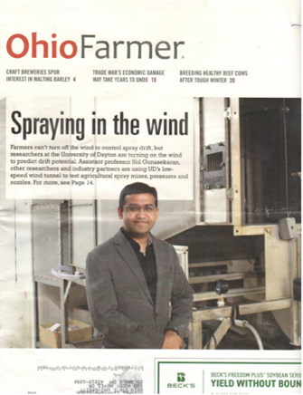
Figure 3.1 Spray Drift Testing and Research Recognized by the Ohio Farmer’s Magazine
- University of Dayton Wind Tunnel Used For Agricultural Chemical, Equipment Testing, ASEE First Bell, Jun 10, 2019
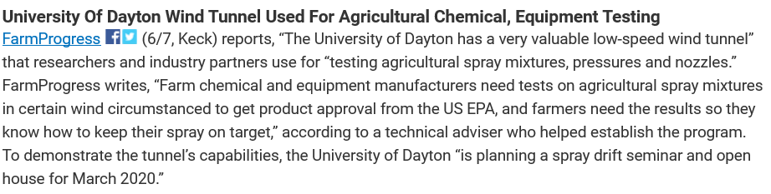
Figure 3.2 Spray Drift Testing and Research Recognized in the ASEE First Bell

- University of Dayton. (2022, March 11). Using Machine Learning to Minimize Spray Drift. YouTube. Retrieved June 18, 2022, from https://www.youtube.com/watch?v=zZs8T2pB2Os

- Low-speed wind tunnel. Projects : University of Dayton, Ohio. Retrieved June 18, 2022, from https://udayton.edu/engineering/research/research-labs/wind-tunnel/projects.php

VIII. From Sponsors and PMs:

“I have come to know Dr. Gunasekaran over the past year as he has led, as the principal investigator, an effort to apply traditional and enhanced machine learning predictive tools to flow control. For this (DARPA) project, the value of monitoring the technical progress far exceeded the funding provided. In addition, I believe that the computational tools delivered shall have an impact on the Multidisciplinary Science and Technology Center (MSTC) conceptual and preliminary design tools. This project was an excellent example of how the methods and processes that have been developed in academia can impact the design process, as well as the physical design, of a technology demonstration vehicle.”
- Edwin Forster, Senior Aerospace Engineer, AFRL
Please see the rest of the letter of support from Dr.Ed Forster, technical advisor for my DARPA project in Tab 10 of the dossier.
“Sid’s leadership and determination was the critical driver in achieving the testing capabilities that are now located at the university. This provides the university a bridge to work with industry and government agencies with the goals of moving the science of agriculture forward. As drone spray research becomes more of a focus in the industry, it is likely that we will see more interest in understanding the spray dynamics. Given his expertise in aerodynamics and our testing capabilities, we are uniquely positioned to study and inform the industry regarding this new frontier in agriculture.”
Please see the rest of the letter of support from Mr. Kyle Butz, technical advisor for Spray Analytics in Tab 10 of the dossier.
Faculty Self-Evaluation:
Accomplished
Comments:
Since 2016, I have secured funding from government, industry, and Kern Family foundation, despite me being a non-US Citizen without a green card. I have been awarded two competitive DAGSI grants, a grant from BASF, the leading chemical manufacturer in US, and a grant from DARPA, one of the most prestigious government agencies. Even though it is not mentioned above, I have submitted two white papers for AFOSR and have been establishing relationship with the program manager, Dr. Gregg Abate (Evidence included in Tab 10). I am striving to acquire the AFOSR grant. The University of Dayton Wind Tunnel was featured in Ohio Farmers magazine and in ASEE First Bell for becoming the second non-government wind tunnel in the country to have EPA authorization to perform drift reduction technology research. Funding from KEEN and Industry clients will continue well into the future. For these reasons, I self-evaluate myself as accomplished in acquiring funding.
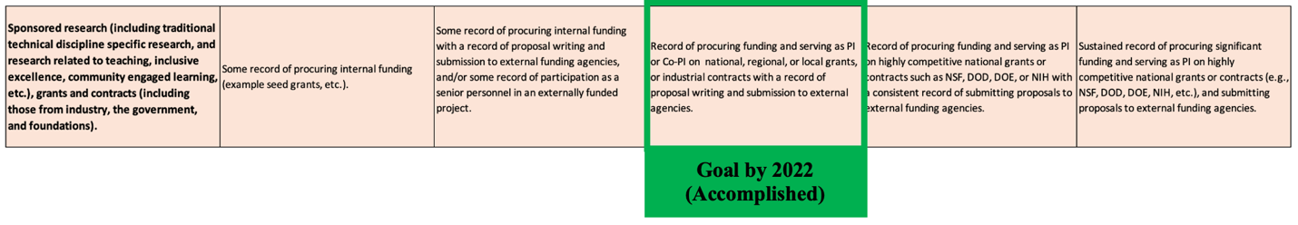
Department Faculty Development Committee Assessment (To be completed ONLY when the faculty member is going up for midterm or tenure and/or promotion review)
Choose an item.
Comments (optional):

Department Chair Assessment:
Choose an item.
Comments (optional):

School of Engineering Faculty Development Committee (To be completed ONLY when the faculty member is going up for midterm or tenure and/or promotion review)
Choose an item.
Comments (optional):

Associate Dean for Faculty and Staff Development:
Choose an item.
Comments (optional):

Element 4: Teaching effectiveness including technical competence, student learning and motivation, classroom management and organization

List of Activities or Evidence to support progress for this Element.

Criteria 1: Routinely employs effective techniques and strategies to create an inclusive learning environment.

In all my courses, students have a wide range of knowledge base, different abilities, different ways of learning, and understanding the material. To make sure each student in the class is challenged, achieve the same amount of increment in learning, and have a sense of belonging in the classroom, I routinely employ the following techniques and strategies:

1. Caring About Students
I let my students know that I care about their learning and growth as a person by trying to learn their names from Day 1 and continue to maintain a healthy student-faculty relationship and caring about their life both inside and outside academia. Students’ reflection in their SETs indicate that this makes a world of difference. Some of the student reflections from various courses are mentioned below –

“Sid really cares about all of his students and will teach something to you over and over again if you don't understand. Additionally, he always welcomes questions about things that are related to the course but not directly. The only regret that I have is that I am not an aero concentration so I will not be able to take him for more courses. Sid is the best.”

“Absolutely fantastic learning environment, with a small class size and lots of individual attention.”

“I liked how fluid the class felt as well as how transparent Sid is. he can be reached at any time for anything.”

“Dr. Gunasekaran was an amazing instructor, demonstrating genuine passion for the field and a serious desire to promote student learning. He kept in regular contact with the class and answered every question thoroughly and attentively. Lecture content and outside experiments were engaging and challenging - but not usually to the extent of being unproductive. I feel that I have had 110 percent growth in the subject area since taking the class and am very prepared for the next step in the aerospace engineering concentration.”

“Sid - Thank you for always bringing the joy to learning and continuing to push me even when I feel like giving up”

I have also attached my current and past students’ letters of support as evidence that I employ this strategy.

2. Scaffolding
To achieve high levels of Bloom’s taxonomy and to make sure each student, no matter the background can follow along the course, I always scaffold my courses where each week’s work is built on the previous week’s work so that the “story” presents itself to the students and allows them to obtain the satisfaction of discovery which builds confidence. It also allows them to put the pieces together to synthesize and evaluate the concepts. Some of the student reflections from various courses are mentioned below –

“The mixture of guided notes, powerpoints, matlab coding, and project all essentially played a different role in my understanding of the course and each part allowed me to learn a different aspect of the course.”

“The instructor's organization was second-to-none. Everything on Isidore was well-organized and easy to navigate. Weekly checklists were helpful when keeping track of homework, lecture video, forum discussion, and quiz completion. Lecture notes and homework assignments had clear logical flow and were easy to follow. It is obvious the instructor spent an immense amount of time converting course materials in preparation for virtual learning. Occasional errors in the lecture notes were minor compared to the delicate balance of detail versus brevity he achieved for each topic.”

“The most effective aspect of this course was simply its structure. Each week’s assignment really felt like it built on the last. This reinforced a lot of learning and made the final product of flying in the simulator really worth it. Office hours were extremely useful and I thank you for taking so much of your time to help this class.”

3. Using Small-Groups to Create a Non-Competitive Ways of Learning
Most students are shy when it comes to participating in classroom activities. However, they all feel comfortable in participating in small groups. As such, I routinely employ small group-based activities both inside and outside the classroom. This allows for each student in the class to have a voice and have their ideas heard by others which builds confidence and character. I also employ a lot of project-based activities where students need to work in small groups for data analysis, wind tunnel testing, and flight simulator simulation activities. Some of the student reflections from various courses are mentioned below –

“Getting put in a group for the RC airplane project gave me a group to ask questions in, mainly homework-related, and other people could ask me questions and I believe if you can teach someone else about the topic you know the topic.”

“The group discussions were useful in understanding the material. Additionally, the homework was well done and were able to be comprehensive and a good way to review and learn the material but not too much that it would be too much work.”

“I enjoyed the classroom because we got to sit in tables and there were screens all around so everyone could see. I enjoyed the class being discussion based and the portfolios made sure I actually understood the material.”

“Overall, I have really enjoyed this class. I like the discussion based set up, it really helped me understand a lot of the more complicated topics we cover. A lot of the topics we covered early on we ended up building on later in the class and it was interesting to see how everything builds on each other. One of the things that amazes me the most that we learned about is some of the derivations we covered. Some of these I can barely understand, but I even have the help of the internet and software like Matlab to help me grasp these concepts, yet the people who originally derived these equations had a pencil and paper, and maybe a slide rule. If they could achieve that much with their resources, I am sure that we will be able to increase our limited knowledge much more. This is only my second class that deals with Aerospace related topics, but I feel I have learned a lot and will have a good foundation to build on for classes that I will take in the future.”

My emphasis on group effort is also evidenced in the peer evaluation of teaching. I have also attached my current and past students’ letters of support as evidence that I employ this strategy.

4. Hands-on Approach to Learning
As a student, I firsthand experienced what hands-on learning could do to build confidence and apply and synthesize technical concepts. My exposure to hands-on learning as a student is what made me an experimental aerodynamicist and it is where I found my calling. I want to give my students the same opportunity. As such, I routinely employ hands-on based learning in all my courses. I make use of the low-speed wind tunnel, the water tunnel, and the flight simulator in all the courses I teach, and I encourage other faculty members to use these facilities in their courses as well. For many students, the hands-on portion of the class is where they learned the most. Some of the student reflections from various courses are mentioned below –
“I had a lot of fun working in the wind tunnel being able to test and apply what we learned in class. The second project we did, creating Joukowski Airfoils was my favorite of the two. Just learning about the Joukowski transformation was fascinating, and I enjoyed being able to apply it even more. I had a role in testing and picking which transformation we would use for three of the airfoils. Although we had many struggles with the wind tunnel gremlins I enjoyed my time experimenting.”

“The passion projects were also a great opportunity to get in the wind tunnel and get some very practical experience running the tunnel and analyzing data collected from experiments.”

“The Passion Projects were the first time I’ve gotten to research and test something on that scale and of my own interest. Though the math was difficult, I know this is the class that I will remember the most from conceptually. Coming into UD I didn’t know where I wanted to take my Mechanical Engineering Degree, however through my journey I have learned that I am extremely interested in aerospace and this class just increased my desire to go into aerospace engineering. Though it is going to be extremely difficult, I hope to eventually get my masters in this field. Thank you for the great semester.”

“The skills we developed in XFLR5, in the windtunnel and in Matlab will be with me for a very long time. I really appreciated this class, it was a lot of work and made me passionate about the subject!”

I have also attached my current and past students’ letters of support as evidence that I employ this strategy.

5. Using Portfolios as a Means of Assessment
In all my courses, I employ portfolio-based assessment technique where students write what they learned from various aspects of the class in their own words. Portfolio gives each students a platform to only show what they learned but to learn through reflection and inquiry regardless of their background. Once again, it gives students a platform to have their voice heard without the fear of being wrong in a public environment. It is a platform for interaction with students where significant misconceptions are made clearly visible and can be addressed immediately. It takes a significant amount of time for students to write portfolios and even more so for me to grade them. However, the impact it has on students provides constant motivation for me to continue offer portfolio-based assessment in all my courses. Some of the student reflections from various courses are mentioned below –

“Dr. Gunasekaran presents the material in an engaging and though provoking manor. His portfolio style is more work than a traditional class but has its rewards in mastery of the topic taught.”

“The portfolio style of homework was very effective in helping me learn and remember concepts.”

“I thought it was helpful to discuss things among our tables before discussing as a class. Although the portfolio was a ton of work, I think I really learned from it and deepened my understanding of aerodynamics.”

“The portfolio based provided an in-depth learning opportunity for each of the subjects covered over the course of the semester.”

“I really feel like I learn the most in regard to application of engineering concepts in these portfolio classes.”

“I thought I would hate the portfolio method that I heard so many rumors about. But, in all honestly, it is a very effective manner for learning.”

“I really like the class structure you have where there are no tests (Which I'm personally bad at) but rather the entire course is centered around a portfolio that continuously builds upon itself and forces me to think about what I learned and put it on paper in my own words which makes it a much better reference for me in the future than any textbook or class notes. I wish every single class in college was structured this way.”

“When I explain to people that I do not have tests and quizzes, they look at me like I am overthinking a relatively easy course. However, what is demanded for the homework and because of the revisions, I have made, I know the material better than I would with any tests or quizzes, because I have had to explain it, multiple times!”

I have published the following ASEE papers on using portfolios to develop an Integrated Teaching model:

- Gunasekaran, Sidaard. "Integrated Teaching Model in Graduate Aerospace Classes: A Trial With Compressible Flow Aerodynamics." ASEE Annual Conference and Exposition. 2017. https://doi.org/10.18260/1-2--28546
- Gunasekaran, Sidaard. "Integrated Teaching Model: A Follow Up with Fundamental Aerodynamics." ASEE Annual Conference and Exposition. 2018. https://peer.asee.org/30677

The use of portfolio to assess the curiosity, connections, and value creation (the 3C’s) is also mentioned in the following magazine and the KEEN Card:

- Gunasekaran, Sidaard and Doug Melton. “Getting EML Off the Ground: Why Do Jets Fly So High?”. KEEN Magazine, p 08. 2017 (https://engineeringunleashed.com/keenzine5/10/)
- Gunasekaran, S., & Melton, D. Why do jets fly so high? Intro to thrust and Jet Engine Design. Engineering Unleashed. Retrieved June 18, 2022, from https://engineeringunleashed.com/card/763

The use of portfolios to measure entrepreneurial mindset is also highlighted in the KEEN video:
- KEEN Network (2019, March 14). How do you measure a mindset? | Sid Gunasekaran. YouTube. Retrieved June 18, 2022, from https://www.youtube.com/watch?v=fvyMMCsW3bM&list=PLvITFYQeu1sG_sZGG7pyxVVLOzMynnJ2z&index=4&t=50s

The school of engineering recognized the impact the portfolio has on student learning and awarded me the 2018 VISION award for Innovation in Teaching. The details can be found in the following links:
- Zandvoort, A. (2019) Faculty and staff recognized with 2018 vision awards. Faculty and Staff Recognized with 2018 Vision Awards : University of Dayton, Ohio. Retrieved June 18, 2022, from https://udayton.edu/blogs/engineering/2018/18-09-13-vision-awards.php

Criteria 2: Consistently demonstrates highly effective teaching through self-reflection and peer evaluations of teaching in all classes.

Reflection is an integral part of portfolio-based learning. While I assess students’ learning through their reflection, I also assess my teaching through self-reflection and peer evaluations of teaching. I routinely share my self-reflection after each class to my students through Isidore as shown in Figure 4.1 (presented as evidence). The self-reflection allows me to accommodate students’ learning and adjust the pace of the class, reflect the high’s and low’s of the class and what I can do better in the next class. The peer evaluations of teaching are shown in Tab 8b.

Figure 4.1 My reflections after each class shared with students on Isidore

Criteria 3: Employs a philosophy of continuous improvement by seeking feedback from students and peers.

One of the rudimentary ways to quantify effective teaching is through student evaluation of teaching (SET) scores. The table below shows the SET scores in each course that I taught since 2016.

 |  |  |  |  | Course Evaluation |  |  | Instr.  Eval
First  Taught | Major Revision | Term | Course # | Course Name | Q. 8 | Q.9 | Q.10 | Q.11 | Response  /Expected
X |  | Fall 2016 | AEE 553 | Compressible Flow* | 4.20 | 4.20 | 3.50 | 3.70 | 75%
X |  | Fall 2016 | MEE 225 | Introduction to Flight* | 4.80 | 4.60 | 3.40 | 3.40 | 33%
X |  | Spring 2017 | AEE 501/MEE 401 | Aerodynamics* | 4.60 | 4.80 | 4.60 | 4.90 | 39%
X |  | Spring 2017 | MEE 312L-01 | Materials Lab | 5.00 | 4.70 | 4.70 | 4.00 | 27%
 |  | Spring 2017 | MEE 312L-04 | Materials Lab | 4.50 | 4.50 | 4.40 | 4.40 | 80%
 |  | Spring 2017 | MEE 312L-05 | Materials Lab | 4.00 | 4.00 | 4.00 | 3.00 | 18%
X |  | Fall 2017 | MEE 312 | Engineering Materials | 4.50 | 4.40 | 4.20 | 4.80 | 36%
 | X | Fall 2017 | MEE 225 | Introduction to Flight* | 4.50 | 4.50 | 4.00 | 3.50 | 39%
 |  | Spring 2018 | MEE 312 | Engineering Materials | 4.70 | 4.60 | 4.50 | 4.60 | 94%
 |  | Spring 2018 | MEE 401 | Aerodynamics* | 4.70 | 4.80 | 4.40 | 4.70 | 90%
 |  | Summer 2018 | AEE 501 | Aerodynamics* | 4.8 | 4.8 | 4.3 | 4.8 | 100%
 | X | Fall 2018 | AEE 501 | Aerodynamics* | 4.9 | 4.9 | 4.5 | 4.7 | 100%
 | X | Fall 2018 | AEE 553 | Compressible Flow* | 4.8 | 4.9 | 4.7 | 4.9 | 93.75%
X |  | Spring 2019 | AEE 590 | Experimental Aerodynamics* | 4.4 | 4.3 | 3.5 | 4.1 | 92.31%
 |  | Spring 2019 | MEE 225 | Introduction to Flight* | 4.9 | 4.8 | 4.7 | 4.7 | 100%
 |  | Summer 2019 | AEE 501 | Aerodynamics* | 5.0 | 4.8 | 4.8 | 5.0 | 57.14%
 |  | Fall 2019 | AEE 501 | Aerodynamics* | 4.8 | 4.7 | 4.1 | 4.3 | 100%
X |  | Fall 2019 | AEE 555 | Turbulence* | 4.4 | 4.6 | 4.0 | 4.5 | 92.86%
 | X | Spring 2020 | MEE 225 | Introduction to Flight* | 5.0 | 5.0 | 5.0 | 4.3 | 23.08%
 |  | Spring 2020 | MEE 401 | Aerodynamics* | 4.8 | 4.9 | 4.8 | 4.6 | 33.33%
X |  | Fall 2020 | MEE 425 | Aircraft Design* | 4.7 | 4.7 | 4.7 | 4.8 | 100%
 | X | Fall 2020 | AEE 501 | Aerodynamics* | 4.8 | 4.8 | 4.3 | 4.5 | 81.25%
 | X | Fall 2020 | AEE 553 | Compressible Flow* | 5.0 | 5.0 | 4.8 | 4.9 | 90.91%
 | X | Spring 2021 | AEE 590 | Experimental Aerodynamics* | 4.7 | 4.7 | 3.3 | 3.7 | 33.33%
 |  | Spring 2021 | MEE 225 | Introduction to Flight* | 4.1 | 4.1 | 3.9 | 3.6 | 94.12%
 |  | Spring 2021 | MEE 401 | Aerodynamics* | 4.7 | 4.6 | 4.3 | 4.6 | 100%
 |  | Fall 2021 | AEE 501 | Aerodynamics* | 4.7 | 4.7 | 4.4 | 4.5 | 100%
 |  | Fall 2021 | MEE 425 | Aircraft Design* | 4.7 | 4.7 | 4.7 | 4.8 | 100%
 |  | Spring 2022 | MEE 225 | Intro to Flight* | 4.5 | 4.2 | 3.8 | 3.6 | 100%
 |  | Spring 2022 | AEE 590 | Experimental Aerodynamics* | 5.0 | 4.9 | 4.6 | 4.7 | 100%
X |  | Summer 2022 | AEE 590 | Advanced Data Science and Machine Learning Applied to Aerodynamics | In Progress
 |  |  |  | Sid’s AVERAGE | 4.67 | 4.65 | 4.30 | 4.36 | 74%
 |  |  |  | AVERAGE of DEPARTMENT ACROSS ALL YEARS | 4.35 | 4.26 | 4.19 | 4.30

Since 2016, I have taught over 9 new courses, several of which was revamped through major revisions. By combining all the scores, it was calculated that the average teaching scores for course content was 4.54/5 and for the instructor was 4.36/5 which are above the department average. The courses with (*) are taught using portfolio-based pedagogy and assessment where each student wrote an elaborate technical portfolio (around 150 pages on an average with 11point font, single spacing) containing a detailed narrative of everything they learned in the class along with reflections. I use these scores and qualitative feedback to improve on my teaching each semester. I also constantly obtain anonymous feedback and Likert scale assessments from students’ multiple times throughout the semester. Some of the student reflections from SETs are mentioned below –

“Sid is a great guy and is always willing to give feedback and make sure that we are understanding the content. He frequently polled the class on how we felt about the material and how it was presented and was even willing to adjust his methods of presenting material in order to support our learning. He pushed us to dive deeper into some topics and apply what we learned, as well as reflecting on our learning.”

“Professor allowed homework iterations, so we get better grades if we didn’t do well the first time (no permanent failure for making mistakes). Professor would slow down if we were having difficulty understanding topic. Professor was constantly seeking feedback throughout the semester so he could improve his teaching style in order to help students learn better.”

Criteria 4: Routinely employs novel teaching techniques and best practices such as active and collaborative learning, community engaged learning and entrepreneurial minded learning in all courses taught.

1. Integrated Teaching Model
One of the novel learning techniques that I employed is to use portfolio to build an integrated teaching model mentioned earlier in the section and was documented in the two ASEE papers mentioned above. I developed the integrated teaching model based on the Structure of Observed Learning Outcomes (SOLO) model developed by Collis and Higgs. The integrated teaching model is both instructor-centered and student-centered. The initial scaffolding is done by the instructor in terms of aligning the topics, choosing the mode of learning (projects, problem, inquiry, group discussions, etc.) and then lets the students put the pieces together themselves thereby making the connections necessary to foster enhanced learning.

2. Ideation, Disruption, and Aha (IDA Pedagogy)
The IDA pedagogy is developed by Institute of Applied Creativity for Transformation (IACT) at the University of Dayton. As an IACT fellow, I implemented the IDA pedagogy in my introduction to flight course to inspire applied creativity and humanity centered design using the concept of flight. For two semesters, the introduction to flight classes were conducted at the IACT Art Studio (Figure 4.2) that made deployment of several active learning strategies more effective than the conventional classroom. I have published the following ASEE paper on the use of IDA pedagogy in Introduction to Flight along with the modules, assessment technique and the results:

- Gunasekaran, Sidaard. "Using IDA Pedagogy in Introduction to Flight." In 2019 ASEE Annual Conference & Exposition. 2019. https://peer.asee.org/25203

As a part of the class, students were asked to develop product ideas that used the concept of flight to help day-to-day activities. The IDA inspired process helped students develop several design ideas which were shared at the Dayton-Cincinnati American Institute of Aeronautics and Astronautics (AIAA) chapter’s dinner meeting. The use of IDA pedagogy was highlighted in the December 2017 Issue of Aerospace America Magazine:

- December 2017 AIAA bulletin. Aerospace America. (2018, June 8). Retrieved June 18, 2022, from https://aerospaceamerica.aiaa.org/bulletin/december-2017-aiaa-bulletin/
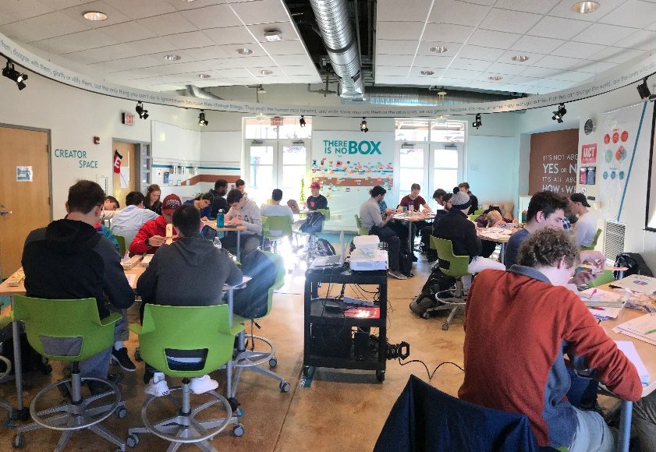
Figure 4.2 MEE 225 Introduction to Flight course held at the Art Studio Classroom
3. Passion Projects
I employ passion projects in most of my courses. When students think back on their formidable experiences in the university, it won’t be the lectures or the classes they take but the opportunity to take ownership over an independent project and pursue a single idea. This experience will cement student’s love for learning and the process of discovery. This was the inherent motivation behind designing the passion projects because it promotes independent study, sustainable and residential learning. It is designed so that students acquire the skillset of scientific investigation through independent research, testing and analysis. Throughout the semester, students choose a passion project of their interest and carry out literature review, building test matrix, wind tunnel testing, and data analysis throughout the semester. The students also teach their peers about what they learned that enhances the quality of conversation and learning in the classroom.
The student passion projects can be seen in the link below –

- Gunasekaran, S. (2017, April 24). MEE 401 Fundamental Aerodynamics Passion Projects. YouTube. Retrieved June 18, 2022, from https://www.youtube.com/watch?v=qcAkG5fuyE8&amp;t=1s
- Gunasekaran, S. (2018, May 16). Aerodynamics Spring 2018 - Passion Projects. YouTube. Retrieved June 18, 2022, from https://www.youtube.com/watch?v=BgBvitqANoM

4. Combining Pedagogy with Technology
I also routinely employ technology to teach, obtain feedback from students, give quizzes, and employ active learning strategies in my classes. In 2017, I used the services provided by TopHat for polls, quizzes, and in-class discussions, and real-time feedback. In 2019, I became a Studio Fellow where I taught AEE 501 Aerodynamics in the teaching studio at the Learning Teaching Center (LTC). I engaged students in several active learning technique using the 15-ft touch screen in the studio as shown in Figure 4.3 and by taking advantage of the glass walls where students can make their thinking visible. I was interviewed by the flyer podcast on the use of LTC studio which can be seen in the link below –
- Curran, A. A Look Inside the LTC studio with Dr. Sidaard Gunasekaran. Listen Notes. Retrieved June 18, 2022, from https://www.listennotes.com/podcasts/flyered/003-a-look-inside-the-ltc-a9Q4OyDTxIC/
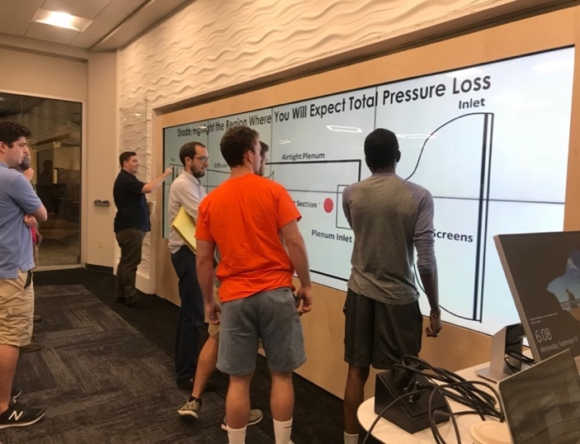
Figure 4.3 Students Interacting with the 15-ft Canvas at the LTC Studio

5. Integrating Entrepreneurial Minded Learning (EML)
The extensive use of Entrepreneurial Minded Learning (EML) and the corresponding evidence is discussed in detail in Elected Elements 2 section of this form. However, the evidence of EML integration can be found in the link below –
- Our Competitive Edge : University of Dayton, Ohio. Retrieved June 18, 2022, from https://udayton.edu/advancement/impact/report-2018/donor/index.php

Criteria 5: Routinely, develops and updates course materials.
Since 2016, I have taught the following courses:
- MEE 225 Introduction to Flight (6X)
- MEE 312 Engineering Materials (2X)
- MEE 312L Engineering Materials Lab (1X)
- MEE 401/AEE 501 Fundamental Aerodynamics (10X)
- MEE 425 Airplane Design (2X)
- AEE 555 Turbulence (1X)
- AEE 553 Compressible Flow (3X)
- AEE 590 Experimental Aerodynamics (3X)
- AEE 590 Advanced Data Science and Machine Learning Applied to Aerodynamics (1X)
The courses I taught covers a wide range from sophomore level to graduate level where knowledge base and maturity levels of students are widely different. Except for MEE 312 Engineering Materials, I follow the portfolio-based learning and assessment in all the other courses listed above. A more detailed overview of the courses and the revisions and updates is shown in Elected Elements 1 section.

Criteria 6: Incorporates some or all the five characteristics of a Marianist education.

Out of the five Marianist characteristics, I incorporate the characteristics associated with “Empowered by excellence, enlightened through service, and transformed for Life” in my classrooms in the following ways:

1. Changing Students’ Mindset
In the beginning of all semesters, use of portfolio in my courses is constantly met with a lot of intransigence from students. It is not what they are used to, it takes more time and effort than preparing for exam, and it requires a bit more mental effort than conventional style. I make it clear to my students that nothing worth doing is ever easy and learning comes from within. Once the students go through the process, they see the benefits for themselves. Below is a qualitative comment from one of the students from SET –

“This is my second course taught by this instructor, and both follow the same pattern. He forces students to work incredibly hard in his classes, but the quality of learning is excellent. It sometimes feels he expects WAY too much out of his students, but the harder you work in his class, the more you learn the material and benefit in the long run. In his classes, he consistently fosters curiosity and encourages independent learning, both of which are indispensable skills I'll use for the rest of my life.”

Students are generally good at answering any questions asked in a homework and do the minimum amount of work to get a good grade. However, doing more than what is asked in a homework, or a project requires creativity, curiosity, agency, and more importantly, responsibility. And this is the essence of being a leader. Through my teaching philosophy and assessment, I don’t just teach my students the technical knowledge but also the grit and the passion to go the extra mile that sets them apart from the crowd.

2. Using the City of Dayton as a Didactic Tool
Dayton is an airplane town. There is no better place to learn about aviation than Dayton. There is a rich aviation history and legacy that not a lot of students are aware of. As such, I routinely integrated required activities involving historical locations and museums around Dayton into my courses. Students are asked to visit and then summarize and reflect on what they learned from the following sites and events around Dayton:
- United States Air Force Museum
- Huffman Prairie Flying Field
- Wright-Dunbar Interpretive Center
I conduct scavenger hunts in the air force museum in my intro to flight and aircraft design course where students are tasked with finding different parts of an airplane. As an advisor for three major aero clubs at UD, I constantly bring my students in classes to help with various outreach programs organized by the local American Institute of Aeronautics and Astronautics (AIAA) branch and constantly remind students that service is an integral part of engineering. I encourage my students to participate in the following events around Dayton:
- WACO Fly-In
- Aero Carnival
- Dayton Air Show
- TechFest at Sinclair Community College

3. Participation in LTC Book Clubs
Since 2016, I have participated in several book clubs organized by Dr. Elizabeth Harrison from LTC where I have read and discussed the following books with my peers across campus that integrates science of learning with teaching

- Cavanagh, Sarah Rose. The spark of learning: Energizing the college classroom with the science of emotion. West Virginia University Press, 2016.
- Church, Mark, Karin Morrison, and R. Ritchhart. Making thinking visible. Nueva York: Jossey-Bass, 2011.
The findings from the research mentioned in these books indicated that all learning begins with emotional stimuli, and that learning can be improved by eliciting particularly positive emotional responses. Emotional stimulating techniques such as creating surmountable gaps in knowledge to stimulate curiosity, suggesting that one size may not fit all approach, and giving students ownership control of their learning, etc. were practiced in the courses I taught.
After finishing the book, I along with the members of my cohort, Dr. Kim Bigelow, Dr. Yvonne Sun, Dr. Kevin Hallinan, Dr. Beth Harrison, and Dr. Aaron Altman created “Passion Meters” which we employed in our course. The passion meters was discussed in the 2018 LTC Newsletter –
- University of Dayton. Ryan C. Harris Learning Teaching Center, "LTC Newsletter" (2018). LTC Newsletter. 30. https://ecommons.udayton.edu/ltc_newsletter/30 (Page 11)

Criteria 7: Provides guidance to other faculty within the University with respect to teaching effectiveness.

I have reached out to both full-time and adjunct faculty within the university to provide guidance on teaching techniques and share some of my teaching philosophy and modules. I have given presentations during SOE Lunch and Learns and presented my teaching to the former Dean, Dean Rojas’ Advisory Council. I have also shared my experiential learning modules and how it can be integrated in the new P and T policy in the Learning Teaching Forum presentation organized by Dr. Kenya Crosson. I have shared my portfolio-style teaching and assessment as well as several entrepreneurial minded learning activities to new faculty using KEEN Fellows meeting. I have attached Dr. Ken Bloemer’s letter of support along with my P and T package as evidence.

I have also been chosen as a faculty ambassador for KEEN, where I have shared my teaching philosophy and modules in the following institutions in-person:

- Valparaiso University
- George Washington University
- Drexel University
- Florida Gulf Coast University
- Duke University
- Michigan Tech University
- Rochester Institute of Technology
- Clarkson University
- Tulane University
- University of Toledo
Some of my teaching modules have been implemented by faculty in other institutions as evidenced by the image below from engineering unleashed –

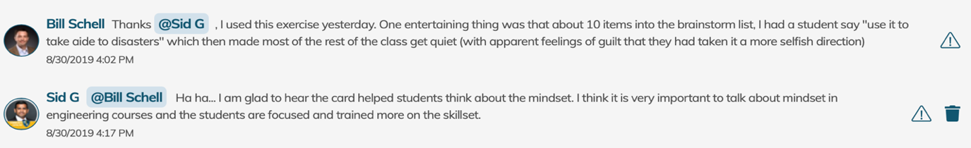
Figure 4.4 Evidence of Teaching Module that I developed being used by Dr. Bill Schell from Montana State University [https://engineeringunleashed.com/card/863]

I have also shared the materials and modules that I developed to other full-time and part-time faculty members in our department:

- AEE 553 Compressible flow course and modules developed over three iterations was shared with Dr. Carson Running when he took over the course.
- MEE 401 and AEE 501 Aerodynamics course and modules developed our several iterations was shared with many adjunct faculty such as Dr. Jose Camberos, Dr. Michael Ol, and Dr. Kasim Biber.

Faculty Self-Evaluation:
Demonstrated Leadership
Comments:
As evidenced by the teaching evaluations, awards, the experiential learning aspect of all my courses, and student feedback, I spend significant amount of time and effort to enhance my teaching effectiveness every single day. It is for these reasons, I evaluate myself as demonstrated leader in teaching.
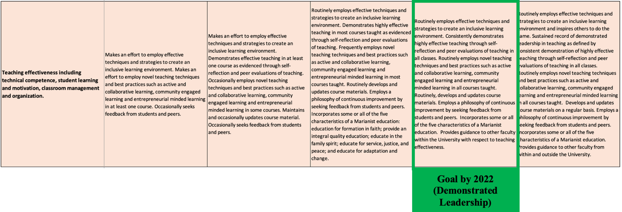
Department Faculty Development Committee Assessment (To be completed ONLY when the faculty member is going up for midterm or tenure and/or promotion review)
Choose an item.
Comments (optional):

Department Chair Assessment:
Choose an item.
Comments (optional):

School of Engineering Faculty Development Committee (To be completed ONLY when the faculty member is going up for midterm or tenure and/or promotion review)
Choose an item.
Comments (optional):

Associate Dean for Faculty and Staff Development:
Choose an item.
Comments (optional):

Element 5: Actively serving on departmental, School or University committee, task force or other formal groups.

List of Activities or Evidence to support progress for this Element.

Criteria 1: Significant contribution to School and/or University level committee or multiple School or departmental committees

1. MEE Department Committee Participation

- Fall 2016 – Present Lead Advisor for several undergraduate thesis and graduate thesis Committee as listed in Element 1

- Fall 2017 - Member of Redefining Department Mission Statement Committee

- Fall 2017 - Member of Redefining Mechanical Engineering Curriculum Committee

- Fall 2019 – Member of Faculty Search Committee for Aerospace Faculty

- Spring 2022 – Member of Thermal Science Committee

- Spring 2022 – Helped to establish MAE High Speed Camera Sharing Network

2. School of Engineering Committee Participation

- Spring 2019 – Vision Award Selection Committee

- Summer 2019 – School of Engineering Breakaway at Bergamo Center (Invited by Dean Rojas)

- Spring 2021 – Member in Diversity, Equity, and Inclusion (DEI) Strategic Planning Committee. As a member of this committee, my specific task was to develop Area 2 Goal on Strengthen the recruitment, retention and advancement of diverse faculty, staff and students through the development and use of equitable practices and processes to enhance innovation and excellence.
https://docs.google.com/document/d/1ljI-kg_r0-j9B3NCgFCsjfUsZCAtAprXQduZ_4G44qA/edit

- Spring 2022 – Panelist on Learning Teaching Forum on the topic of the new P and T policy (Organized by Dr. Kenya Crosson)

- Spring 2022 – Became an Equity Advocate in UD Men for Gender Equity Committee

There are only a limited number of committees and task forces that a tenure track faculty member can participate in.

3. University Committee Participation

- Fall 2018 - Faculty Seminar Cohort on “What is the University for?” (Awarded one course release by the provost office)

Faculty Self-Evaluation:
Accomplished
Comments:
As evidenced above, I have served in multiple department level and school of engineering level committee. I have been a part of faculty search committee and spearheaded the establishment of the camera sharing network in the department. I have been a member of the DEI strategic planning committee and I also became an equity advocate in UD Men for Gender Equity Committee. It is for these reasons, I evaluate myself as accomplished in this element.
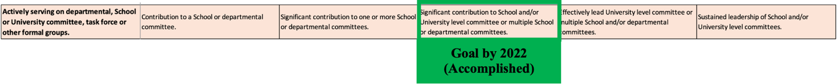

Department Faculty Development Committee Assessment (To be completed ONLY when the faculty member is going up for midterm or tenure and/or promotion review)
Choose an item.
Comments (optional):

Department Chair Assessment
Choose an item.
Comments (optional):

School of Engineering Faculty Development Committee (To be completed ONLY when the faculty member is going up for midterm or tenure and/or promotion review)
Choose an item.
Comments (optional):

Associate Dean for Faculty and Staff Development:
Choose an item.
Comments (optional):

Element 6: Supporting and promoting inclusive excellence in the School of Engineering

List of Activities or Evidence to support progress for this Element.

Criteria 1: Regularly participates in professional development sessions or participates in semester-or year long professional development opportunities associated with diversity, equity, and inclusion and/or intercultural competence

- Spring 2021 – Member in Diversity, Equity, and Inclusion (DEI) Strategic Planning Committee. As a member of this committee, my specific task was to develop Area 2 Goal on Strengthen the recruitment, retention and advancement of diverse faculty, staff and students through the development and use of equitable practices and processes to enhance innovation and excellence. Proposed Goals and list of Tactics - Google Docs

- Spring 2022 – Attended Equity Advocate 101 session

(AND/OR)

Criteria 2: Demonstrates effective use of inclusive practices in the classroom, when working with other faculty or staff, or in advising

A. Engaging Female Aerospace Students to Pursue Research

The field of aerospace engineering, with the exception of astronaut core remains male dominant. Since 2016, I have been striving to have strong female participation in research. I have been actively trying to engage female students to get interested in the field of aerospace engineering and engage them in research. I also constantly seek funding opportunities for them. Below are all the female students from my research group that I have advised.

1. Summer Jenkins (Summer 2018 - SURE program)
2. Faith Loughnane (2018 – 2020 Honors Thesis – Clare Booth Luce Scholar)
3. Rachel Sharp (2019 - 2020 Graduate student – Independent study)
4. Grace Culpepper (2019 – 2021 Honors Thesis – Clare Booth Luce Scholar)
5. Madison Peyton (2020 – 2021 Graduate student – GSSF Awardee)
6. Alexa Roberts (2020 – 2021 Undergraduate student)
7. Ancy Johnson (Fall 2021 Graduate student – Independent study)
8. Rachael Supina (2018 – Present Graduate student – GSSF Awardee)

I have also co-mentored the following female students and serving on their thesis/dissertation committee –
1. Molly Donovan
2. Katie Opacich
3. Jen Colborn
4. Madeline Lickenbrock

B. Developing an Inclusive Research Group and Community both Inside and Outside the Classroom

Since 2016, over 30 students have been through my research group. 2021 has been one of the most productive year terms of many things - papers, projects, proposals, etc. but the most important accomplishment is the sense of community that we developed in my research group and the things that we learned together. We are collaborating more with each other, learning from each other, and working on research that truly matters. Even after graduating some students are willing to work with me to finish the papers and the presentations and the fact that they are willing to do that, which is beyond their call of duty, shows how strong and lasting the community that we built here is. And it is something I will never take for granted. And this has been the most satisfying aspect of my job that I wouldn’t trade for anything else.

In my student’s words who graduated in Spring 2021 –

Hey Sid,
I know we still have a presentation to give next month, but I thought this may be a good time to share some reflections of my own. First off, thank you so much for letting me work on this project. It brings me great joy to see it wrap up this way (and I hope all other projects are going well.) Second, thank you for being so supportive of my goals, even if it meant me not returning to UD. It brought me sadness to leave out on the group, but it was great to hear how excited everyone was that I was pursuing my dream. Third, more as a comment, I very much agree with your thoughts on the research group as a community; they are a truly talented, kind, and overall excellent team to be a part of!
Lastly, I figured this would also be a good time to give you an update on life here: I recently just received the tentative offer for a Pathways internship at NASA Langley! (At this point I am so excited, it all seems too good to be true.)
I look back at the last four years and see a few key moments that are the reason I’ve gotten to this exact point; a lot of the important lessons I learned were in your lab or from picking the brains of talented people around me. Whatever the future holds, I will always be thankful for all the opportunities you gave me.
Thanks again,
Joe

C. Focus on Lifelong Student Learning

Promoting lifelong learning has been the core of my teaching philosophy and style. My focus in all my classes is to transform the student’s mindset from studying for exams to studying for making an impact in the community and society. Using the numerous tools and techniques that I learned from attending many teaching workshops and being a part of KEEN and IACT, I constantly strive to incorporate modules for students that helps them truly understand the concepts and retain the knowledge for a longer time. I have also been a part of LTC Studios Fellows in Fall 2018, which allowed me to incorporate and integrate modern technology with the pedagogy. My teaching methodologies and philosophies have been published in ASEE papers, shown in Element 2 in this document. I have been using portfolio style assessment to promote lifelong learning along with active learning tools such as guided notes, passion projects, etc.

“When I explain to people that I do not have tests and quizzes, they look at me like I am overthinking a relatively easy course. However, what is demanded for the homework and because of the revisions, I have made, I know the material better than I would with any tests or quizzes, because I have had to explain it, multiple times! Additionally, the skills we developed in XFLR5, in the wind tunnel and in Matlab will be with me for a very long time. I really appreciated this class, it was a lot of work and made me passionate about the subject!”

“Lectures were thoroughly thought out to maximize the impact for students. The healthy mix of learning the derivations, functional relationships, applications, and approaching the open-ended homework provided for effective learning and not being a repetitive day in and day out. I also liked that it was more conversational during class rather than the traditional lecturing. I appreciated the opportunities to work on or in groups during class to approach and solve problems first, as it develops confidence in our ability to do it ourselves for a job in the future.”

“Throughout the course, I found the guided notes always seemed to really help me retain information and I also think the homeworks, although sometimes lengthy, did force me to think more deeply about the topics that were covered in order to gain a better understanding of them”

“Another highlight for this class for me were the passion projects. I had a lot of fun working in the wind tunnel being able to test and apply what we learned in class. The second project we did, creating Joukowski Airfoils was my favorite of the two. Just learning about the Joukowski transformation was fascinating, and I enjoyed being able to apply it even more. I had a role in testing and picking which transformation we would use for three of the airfoils. Although we had many struggles with the wind tunnel gremlins I enjoyed my time experimenting. It was a very nice way to wrap up the semester.”

“The Passion Projects were the first time I’ve gotten to research and test something on that scale and of my own interest. Though the math was difficult, I know this is the class that I will remember the most from conceptually. Coming into UD I didn’t know where I wanted to take my Mechanical Engineering Degree, however through my journey I have learned that I am extremely interested in aerospace and this class just increased my desire to go into aerospace engineering. Though it is going to be extremely difficult, I hope to eventually get my masters in this field. Thank you for the great semester.”

(AND/OR)

Criteria 3: Makes significant contributions through active participation on a working group or task force aimed at addressing issues of equity and inclusion at the School level.

- Spring 2022 – Selected as new advocate for UD Men for Gender Equity Initiative
University of Dayton. Women's Center, "UD Men for Gender Equity Newsletter, May 2022" (2022). UD Men for Gender Equity Newsletter. 18.https://ecommons.udayton.edu/men_genderequity_newsletter/18

Faculty Self-Evaluation:
Proficient
Comments:
Even though the DEI is a new initiative in the school of engineering, I am a firm believer in inclusivity and have been an enthusiastic participant in DEI promoting efforts such as the DEI strategic planning committee and UD Men for Gender Equity. There are still ways for me to be involved. As such, I self-evaluate myself as being proficient in this element, edging close to being accomplished.
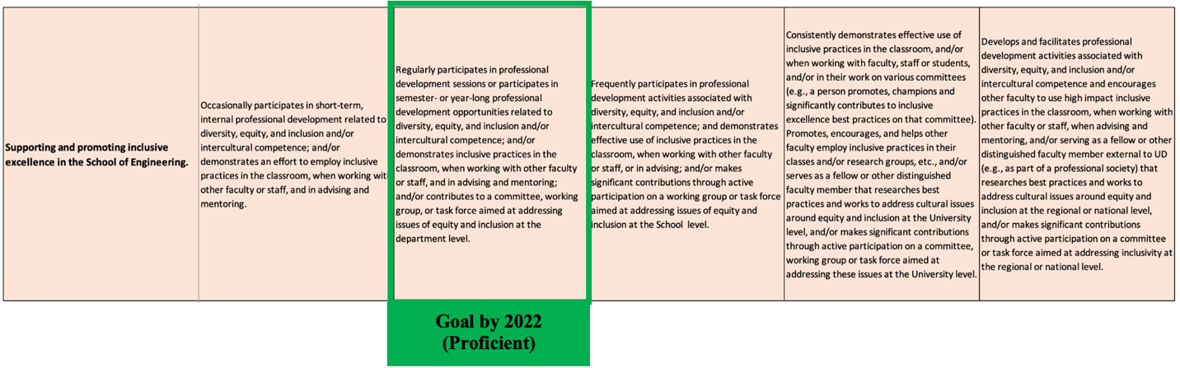
Department Faculty Development Committee Assessment (To be completed ONLY when the faculty member is going up for midterm or tenure and/or promotion review)
Choose an item.
Comments (optional):

Department Chair Assessment:
Choose an item.
Comments (optional):

School of Engineering Faculty Development Committee (To be completed ONLY when the faculty member is going up for midterm or tenure and/or promotion review)
Choose an item.
Comments (optional):

Associate Dean for Faculty and Staff Development:
Choose an item.
Comments (optional):

Elected Element 1: Development of new programs, courses, or significant redesign of existing programs or courses including those offered on campus and online.
List of Activities or Evidence to support progress for this Element.

Criteria 1: Development of several new courses and/or significant redesign of multiple courses that leads or supports the development of a new program.

Since 2016, I have taught the following courses:
- MEE 225 Introduction to Flight (6X) (Significant online content developed due to the pandemic)
- MEE 312 Engineering Materials (2X)
- MEE 312L Engineering Materials Lab (1X)
- MEE 401/AEE 501 Fundamental Aerodynamics (10X) (Significant online content developed due to the pandemic)
- MEE 425 Airplane Design (2X) (Significant online content developed due to the pandemic)
- AEE 555 Turbulence (1X)
- AEE 553 Compressible Flow (3X) (Significant online content developed due to the pandemic)
- AEE 590 Experimental Aerodynamics (3X) (Significant online content developed due to the pandemic)
- AEE 590 Advanced Data Science and Machine Learning Applied to Aerodynamics (In Progress)
I am slated to teach another new course on Unsteady Aerodynamics in the Fall of 2022. While it takes a significant amount of time to develop new materials for teaching new courses, the primary reason for teaching these many courses is to help our MAE department offer our grad students a variety of aero related courses to take at UD related to aerodynamic flows in general. Moreover, I have redesigned some of these courses to incorporate modern pedagogical practices, learning modules, and portfolio-based assessment techniques as well as to cater to the challenges posed by the pandemic. The portfolio-based assessment takes a large amount of time for grading, but it also offers a profound learning experience for the students and promotes lifelong learning.

1. AEE 553 Compressible Flow

I first taught compressible flow in the Fall of 2016. Compressible flow course is a heavily math-based class focused on analysis of governing equations of fluid dynamics in the high Mach number regime Compressible flow is one of the favorite courses that I taught out of all the other courses. The first time I taught it which is the very first semester, I set very high expectations for the students in terms of what I wanted them to achieve using portfolio-based learning. I asked them to write everything they learned from all the classes, projects, homework assignments, article summaries, etc. It simply overwhelmed them, and I didn’t realize it at that time. However, it did allow me to start developing the Integrated Teach Model where I used portfolio as a platform for integration. I published the model, the approach, and the techniques in the following ASEE paper.

- Gunasekaran, Sidaard. "Integrated Teaching Model in Graduate Aerospace Classes: A Trial With Compressible Flow Aerodynamics." ASEE Annual Conference and Exposition. 2017. https://doi.org/10.18260/1-2--28546

A qualitative SET feedback from a student in the class is shown below -
“The course was set up in a pretty good manner for a first time in Compressible Flow. Lectures were thoroughly thought out to maximize the impact for students. The healthy mix of learning the derivations, functional relationships, applications, and approaching the open-ended homework provided for effective learning and not being repetitive day in and day out. I also liked that it was more conversational during class rather than the traditional lecturing. I appreciated the opportunities to work on or in groups during class to approach and solve problems first, as it develops confidence in our ability to do it ourselves for a job in the future.”

I did a major redesign and restructuring of the course in 2018 and presented the material from story-based perspective. Instead of following one textbook, I pulled content from multiple textbooks and aligned the concepts in such a way that it told a cohesive story. Every concept built on top of each other and active and interactive learning strategies and thought exercises to let the equations tell the story to the students. I employed a lot of guided notes in the course and students, and I were excited every single time to come to class. I employed various modules involving real world aircraft such as X-15, F-16, Space Shuttle, etc. and we even role-played NASA scientists designing rocket nozzles using nothing but a poster sheet, a pencil, and a ruler using the method of characteristics. A typical group work in this course is shown in Figure 7.1.
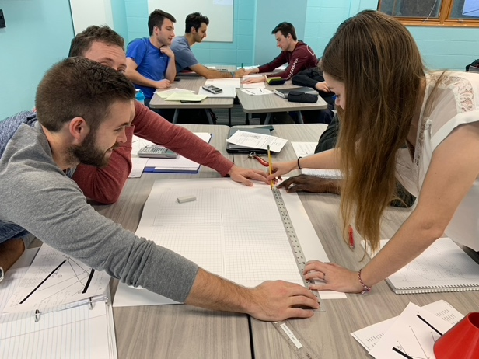
Figure 7. 1 Group work and Interactive Learning Environment in AEE 553 Compressible Flow course
Since I couldn’t do some of the hands-on activities during the pandemic, I had to develop a bit more content and redesign the course to be held completely online. But even then, I retained the story element and students loved it. Out of all the classes, compressible flow was a memorable and a rewarding experience for me and my students. Something about the course felt just right. I have students who have taken almost all my courses and they all will say, this was their favorite course of all. I share their sentiment as well.
In student’s words from SETs:

“The most effective part of the course was explaining what we know. You can’t BS your way through this course if the instructor asks you to explain a concept point blank”

“I enjoyed the classroom because we got to sit in tables and there were screens all around so everyone could see. I enjoyed the class being discussion based and the portfolios made sure I actually understood the material.”

“The lectures were engaging and informative, effectively combining derivations with application-based discussions. The homework assignments were well structured to build from the in-class lectures.”
The overall SET scores from AEE 553 Compressible flow course are shown in Figure 7.2 across all the years that I have taught the course.
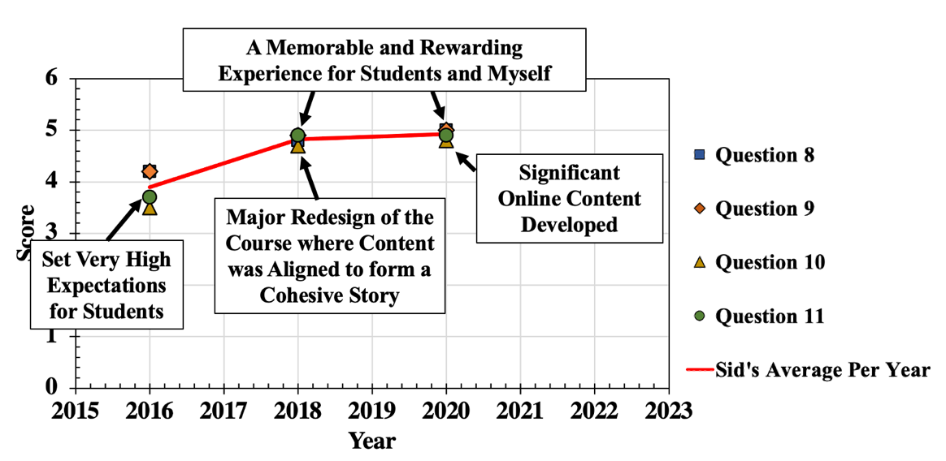
Figure 7. 2 General trends seen in SET scores from AEE 553 Compressible flow course with redesign and modifications

2. MEE 401/AEE 501 Fundamental Aerodynamics

I have taught aerodynamics around 10 times since 2017 in both undergraduate format and graduate format. Until 2018, the department used to offer MEE401 and AEE 501 as a combined undergraduate and graduate class. In 2018, the class was split into separate undergraduate (MEE 401) and graduate (AEE 501) course so that advanced topics such as panel methods, lattice methods, propeller aerodynamics, and unsteady aerodynamics could be incorporated into AEE 501. It is in this semester I taught this course in the LTC Studio for which I had to create 15ft slides and structure the class to take advantage of the technology.

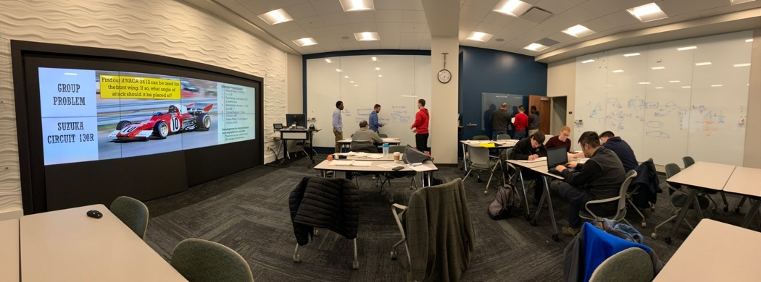
Figure 7. 3 Group work and Interactive Learning Environment in AEE 501 Compressible Flow Course
Like compressible flow, fundamental aerodynamics course is filled with derivations and complicated mathematics. I have employed a variety of modern pedagogical practices in this course such as problem-based learning, project-based learning, inquiry-based learning, entrepreneurial minded learning, and active learning techniques such as think pair share, gallery walk, jigsaw, question formulation technique, etc. to achieve all the levels of Bloom’s taxonomy. A simple derivation of theorems and equations on the board does not excite the students. Hence, the course was redesigned to focus on the application of equations rather than the derivation of them. To focus on the applications, the following practices and modules were introduced into the course:

1. Modified Portfolio based assessment (published in my 2018 ASEE paper)
2. Guided notes for derivations
3. Developing visual aids for complicated concepts
4. Surprise quizzes after the break
5. Instructor reflections after each class in Isidore
6. Passion projects
7. 3C’s infused rubric for each homework assignment

The pedagogy, modules and assessment are detailed in the following paper –
- Gunasekaran, Sidaard. "Integrated Teaching Model: A Follow Up with Fundamental Aerodynamics." ASEE Annual Conference and Exposition. 2018. https://peer.asee.org/30677

I introduced passion project in this course which was a huge success among students.

The student passion projects can be seen in the link below –
- Gunasekaran, S. (2017, April 24). MEE 401 Fundamental Aerodynamics Passion Projects. YouTube. Retrieved June 18, 2022, from https://www.youtube.com/watch?v=qcAkG5fuyE8&amp;t=1s
- Gunasekaran, S. (2018, May 16). Aerodynamics Spring 2018 - Passion Projects. YouTube. Retrieved June 18, 2022, from https://www.youtube.com/watch?v=BgBvitqANoM

The passion projects were also featured in the following article -
- Garrow, K. New classroom approach brings passion to the forefront of learning : University of Dayton, Ohio. Retrieved June 18, 2022, from https://udayton.edu/blogs/engineering/2017/17-05-19-sidaard-gunasekaran-mee-aero.php
Qualitative SET feedback from students are shown below -

“There are times when I hated this class, namely whenever I spent copious amounts of time on it, not, mind you, because I did not want to learn the material but rather, because I did not have enough time. This class took most of my week. Sometimes I felt like I was in the graduate section. Yet, that is not necessarily a bad thing. One of my main complaints since coming to college is that I never feel like I am being pushed enough. That doesn’t mean that I want to go around frustrated and confused because professors are making concepts harder than they need to be. Rather I want professors to push me individually to become better. I get that from Aerodynamics. I honestly have no idea how you do it Sid. Your commitment to your students is truly impressive and I highly appreciate it. The work load is crazy and yet, since it is not busy work and all of it is read and commented on, I don’t mind.”

“I have learned a lot from this class. When I moved to the front of the class and started answering the questions things started clicking more quickly and permanently because I was being led in the right direction but I was the one who was piecing it together as we went. The handouts were additionally very useful, I liked to work ahead a bit and see if my train of thought was headed in the right direction. My favorite was the day we did the source-panel method and it clicked that by putting the surface on the streamline we could determine the vortex, I think everyone else knew it the entire time; it was probably on the handout somewhere. However, for me as the words left my mouth it felt like I had come up with the idea myself and I was struck by how ingenious of a method it was. There were other concepts which I would never have come up with, my reflections on the Joukowski Transformation probably expressed that. More recently, Prandtl’s lifting line theory is still blowing my mind. These people were ingenious!”

“When I explain to people that I do not have tests and quizzes, they look at me like I am overthinking a relatively easy course. However, what is demanded for the homework and because of the revisions, I have made, I know the material better than I would with any tests or quizzes, because I have had to explain it, multiple times! Additionally, the skills we developed in XFLR5, in the wind tunnel and in MATLAB will be with me for a very long time. I really appreciated this class, it was a lot of work and made me passionate about the subject!”

Out of all the portfolio-based classes I have taught, students are less intransigent in this course than any other courses. No matter how much I expect from the students, they always seem to achieve it and they are happy about writing and putting the work.

Since I couldn’t do some of the hands-on activities and discussion-based approach in remote fashion during the pandemic, I had to develop a bit more content and redesign the course to be held completely online. The qualitative comments in 2020 indicated that students loved how I conducted the course using a highly structured content and style using the Isidore lesson page that left little room for any misunderstandings by the students. The one aspect that the students are not happy about in this course is MATLAB coding and in 2019 batch of students struggled a lot with MATLAB coding.

The overall SET scores from MEE 401 and AEE 501 are shown in Figure 7.4 across all the years that I have taught the course
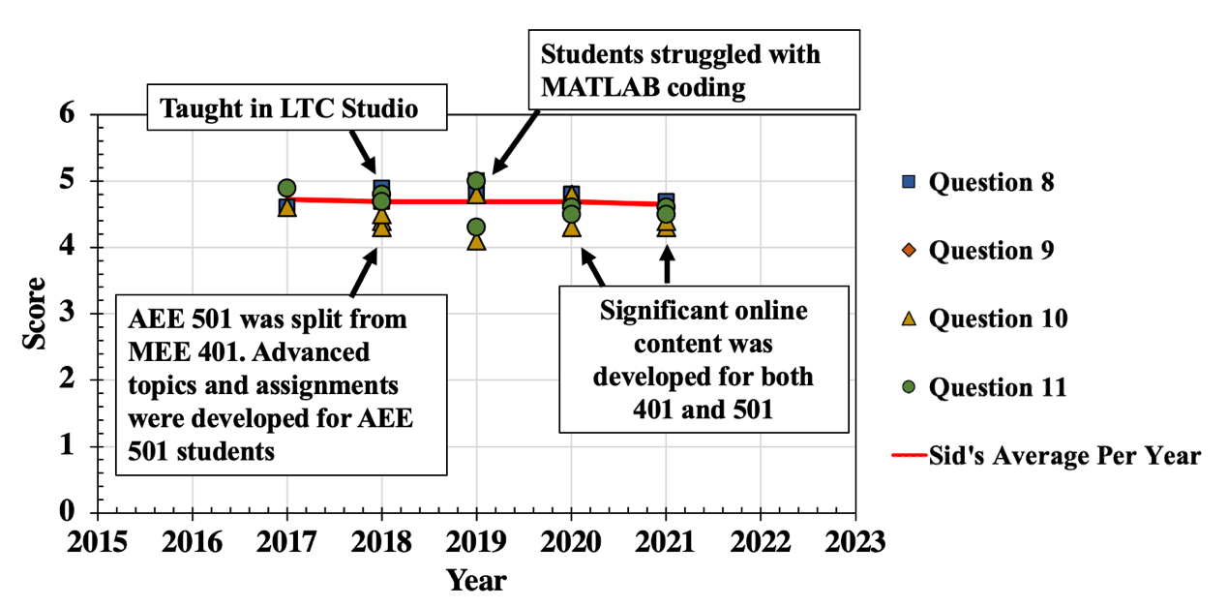
Figure 7. 4 General trends seen in SET scores from MEE 401 and AEE 501 course with redesign and modifications

3. MEE 225 Introduction to Flight

I first taught Introduction to Flight in the Fall of 2016 and I wanted to engage the students in variety of ways to invoke their curiosity about aviation. In 2017 and in 2019, I taught the course in the Art Street Studio. It had walls where students can write on that allowed for me to conduct a discussion style class.

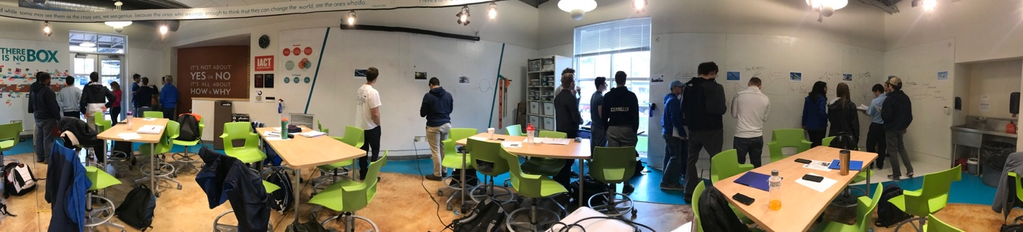
Figure 7. 5 MEE 225 Intro to Flight Students doing Gallery Walk activity in the Art Studio Classroom
The EML module developed in this course called “Why do Jets Fly So High?” was featured in the 2017 KEEN Magazine:

- Gunasekaran, Sidaard and Doug Melton. “Getting EML Off the Ground: Why Do Jets Fly So High?”. KEEN Magazine, p 08. 2017 (https://engineeringunleashed.com/keenzine5/10/)

Similar to the passion projects, an innovation challenge module was also introduced in this course. The challenge was inspired from my participation in KEEN, Institute of Applied Creativity and Transformation (IACT) and Hanley Sustainability Institute (HSI) and also President Spina’s speech on the university for common good. The concept of flight has always been an intangible contributor to the betterment of society. Although airplanes helped win wars and transport people across the globe, students fail to see a tangible impact the concept of flight has in a short term. Therefore, I introduced a challenge to the students – “How can flight be used on a day-to-day basis by a common man?” This challenge provoked creative ideas from students which was designed and prototyped using 3D printing and some of which even turned into a research project. One of the student ideas from this module is in the process of acquiring a provisional patent. The Ideation, Disruption and Aha (IDA) pedagogy was used to scaffold the module into different stages which are described in the following ASEE paper:

- Gunasekaran, Sidaard. "Using IDA Pedagogy in Introduction to Flight." In 2019 ASEE Annual Conference & Exposition. 2019. https://peer.asee.org/25203

The final product and the process was displayed at the Dayton-Cincinnati American Institute of Aeronautics and Astronautics (AIAA) dinner meeting organized by the AFIT and UD AIAA club. The students presented their posters to the guest speaker Tom Morganfeld, a retired F-35 test pilot and to other professional members from AFRL. This event and the posters, including the IDA pedagogy was featured in the December 2017 issue of Aerospace America.

- December 2017 AIAA bulletin. Aerospace America. (2018, June 8). Retrieved June 18, 2022, from https://aerospaceamerica.aiaa.org/bulletin/december-2017-aiaa-bulletin/

Qualitative SET feedback from students are shown below -

“One aspect of this class that really stood out for me was the innovation challenge. I thoroughly enjoyed the creative freedom to work with a group in order to design an invention that would use flight to help the everyday person. We successfully designed a prototype which we had 3D printed and displayed at the flight club dinner for all to see. I really liked our idea, and I hope to potentially advance the idea to a real working model one day.”

“Despite my complaints, I have to give credit to Sid for the immense amount of work he puts in to this class. The fact that he spends an hour and a half grading a single portfolio boggles my mind, and his attention to detail and perfectionist qualities exceed all expectations. I am thankful to have such an instructor that cares about this topic with a burning passion and is always there for his students. He never hesitates to explain something, or draw a diagram, or make sure everyone understands before moving on. Without him, this class would be near impossible.”

In the Spring of 2021, I once again revamped the course to include R/C aircraft design. Students learned about the concepts of flight by designing and building an R/C aircraft. This involves the knowledge of electronics along with the concepts of flight. Each R/C aircraft was tested by R/C aircraft pilot Mr. Chris Fry at the end of the semester. This experiential learning activity was shared on university’s blog.

“I have taken aerospace courses prior to this one, and I can honestly say that this one was my favorite. I not only learned the most from this course, but I liked that it discussed the basic aspects of airplanes and aircraft design. I wish I had taken this class before everything, not only would that have made everything else make a lot more sense, but also this course allowed me to see what aerospace is as a whole."

The R/C aircraft design, build, and fly approach to teaching are featured in the following article -
- Updyke, K. (June 10, 2021). When passion takes flight. University of Dayton, Ohio. Retrieved June 18, 2022, from https://udayton.edu/blogs/engineering/2021/21-06-10-mee225-gunasekaran-sid.php

The overall SET scores from MEE 225 Introduction to Flight are shown in Figure 7.6 across all the years that I have taught the course. I have taught the course six different times and out of all my SET scores, the SET scores from this course are the lowest. It could be because I have implemented a variety of different pedagogies, assessment techniques, active learning strategies, technology integration, and significant redesign to the structure and the content of the course. Because I do a portfolio-based assessment method, sophomores don’t always like to spend that much time and effort into the course. I have had the same students who took my intro to flight course take my aerodynamics course and they love the portfolio method but at this stage, I think they are not mature enough to understand the significance of the portfolio-based method. I think at this stage, they are learning how to learn. My highest SET score from this class was during the pandemic. This is because I made the course extremely straightforward that doesn’t elevate students learning to the higher levels of Bloom’s and Anderson’s taxonomy. I got the feeling that they like to told exactly what to do.
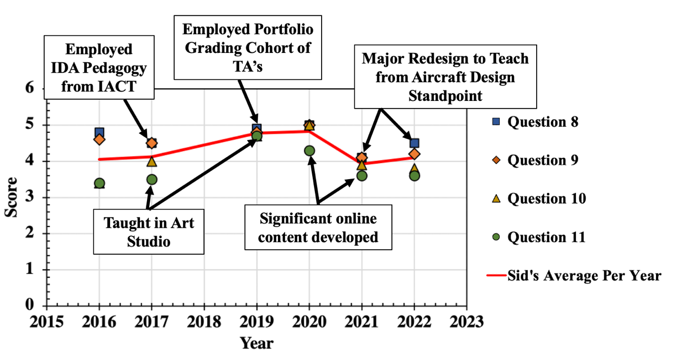
Figure 7. 6 General trends seen in SET scores from MEE 225 Intro to Flight course
But if I make it more open-ended and design-based like in 2021 and 2022, students didn’t quite like it. They feel it’s a bit too involved for an open elective. In 2019, I formed a portfolio grading cohort with 5 of my previous students who have taken my portfolio-based course and let them take three Introduction to flight students under their wings and guide them throughout the semester. It worked extremely well, and students loved it. However, when I just used two graders in 2022, it didn’t work very well. I haven’t found the right recipe yet for this course which is ironic because this course literally has students building airplanes!

4. AEE 590 Experimental Aerodynamics
This course is near and dear to my heart since I am an experimental aerodynamicist by training. Because there is no good textbook for this course, the first time I taught it, I spent most of the time generating content and the lab activities and I was flying by the seat of my pants. I didn’t spend time developing strategies and techniques to deliver the content well. The first time had a lot of theory and very little hands-on portion, and students didn’t like that. The second time I taught this course was during the pandemic and it allowed me to significantly redesign the course and make it entirely project based. In 2021, I had to make it work in a hybrid model where one week, we cover the theory and in the next week, we cover the lab. However, in 2022, I achieved what I wanted, and I was able to achieve a good balance of theory and lab activities. Students loved the fact that the entire course is project-based. The overall SET scores from AEE 590 Experimental Aerodynamics are shown in Figure 7.7 across all the years that I have taught the course.
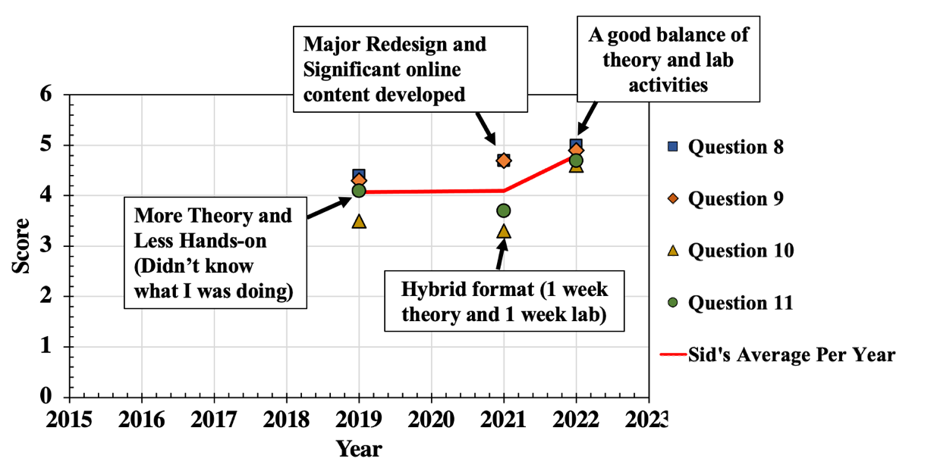
Figure 7. 7 General trends seen in SET scores from AEE 590 Experimental Aerodynamics course
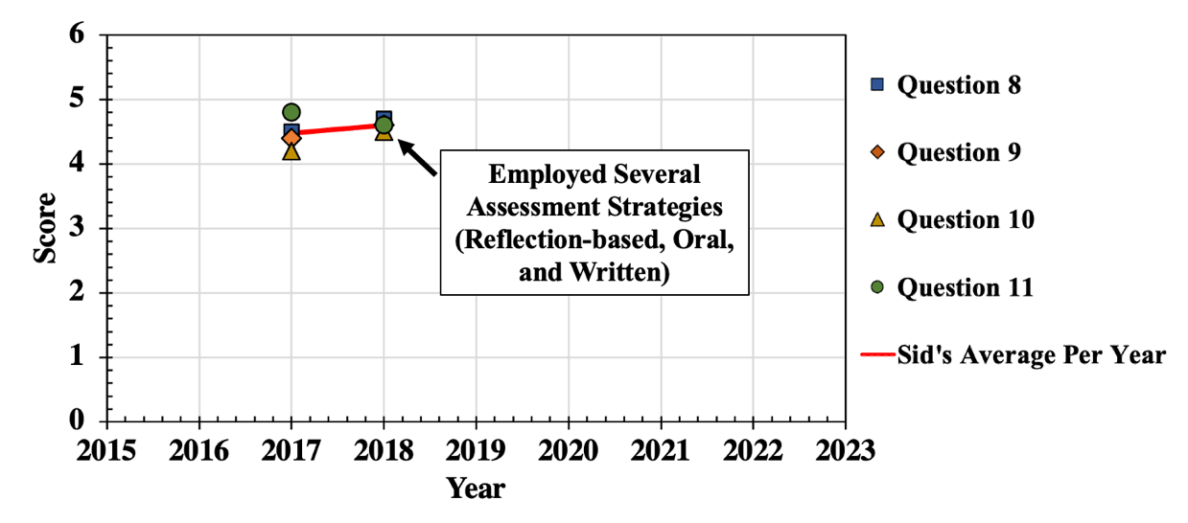
Figure 7. 8 General trends seen in SET scores from MEE 312 Engineering Materials course

5. MEE 312 Engineering Materials
Materials is not my area of expertise, but I was glad to help the department by teaching this course. I was fortunate to have Dr. Pinnell’s notes, and I restructured to make it more aerospace oriented. I added two project-based modules involving materials used in International Space Station and Boeing 787 aircraft that has majority of its components made from composites. I did not use portfolio-based assessment strategies in this course, but I employed several active and interactive learning techniques. The second time I taught the course, I experimented with different assessment strategies such as asking students to write reflections after each assignment and employ mixture of oral exams and written exam for mid-term and finals. The overall SET scores from MEE 312 Engineering Materials course are shown in Figure 7.8 across all the years that I have taught the course
6. MEE 425 Aircraft Design
Unlike experimental aerodynamics course, the problem with aircraft design is that there are way too many good textbooks for this course and as such, it became a challenge to find a right mixture of content that works well for any aircraft class and categories. Like experimental aerodynamics, I made this course to be entirely project-based as well and each project builds on the prior project to arrive at a good conceptual design of an aircraft. The first time I taught this course was also during the pandemic. As such, I had to develop significant online content as well. Like any other courses that I taught during the pandemic, I leveraged the lesson page on Isidore to create a more structured format so that students know exactly what to expect week after week. However, in 2021, I brought it two test pilots from Society of Experimental Test Pilots to fly students designs and give one-on-one feedback. And students loved it! The overall SET scores from MEE 425 Aircraft Design course are shown in Figure 7.9 across all the years that I have taught the course.
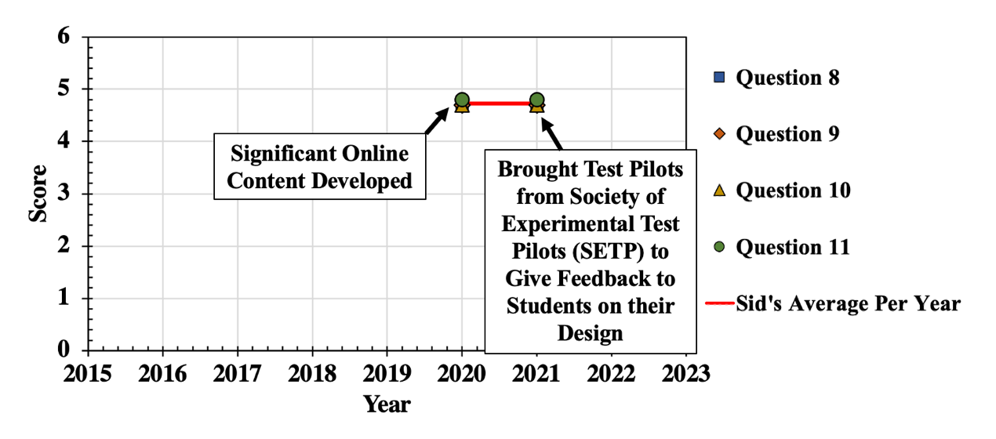
Figure 7. 9 General trends seen in SET scores from MEE 425 Aircraft Design course
The use of flight simulator in the aircraft design and in other courses are featured in the following article -

- Merlin Flight Simulator Lab. Curriculum : University of Dayton, Ohio. Retrieved June 18, 2022, from https://udayton.edu/engineering/research/research-labs/merlin-flight-simulator-lab/curriculum.php

7. MEE 312L Engineering Materials Lab
I only taught MEE 312L Engineering Materials Lab once in 2017 and the average SET score from three sections is shown in Figure 8a. It is a typical lab course where there is a rich hands-on portion for the students. However, I was a bit strict in grading reports and students didn’t quite like putting all that time and effort to the do the report right due to it being a one credit course.
8. AEE 555 Turbulence
I only taught AEE 555 Turbulence once in 2019 and the average SET score is shown in Figure 8b. This class is a bit advanced than other aerodynamics class we offered at UD. The same recipe for active, collaborative, and reflection-based classroom was used just like in all my other courses. Preparation of any new course takes a lot of time, especially a topic as advanced as turbulence. However, I specifically included a lot of reading assignments and asking students to post their reflection on Isidore for everyone in the class to read. Most of my students who tool this class will say that turbulence class was turbulent! We indeed achieve higher levels of Bloom’s taxonomy in this course, but the structure could be improved next time. Since this is the first time I taught this course, majority of time was spent on preparing the content and ways to deliver it in class.
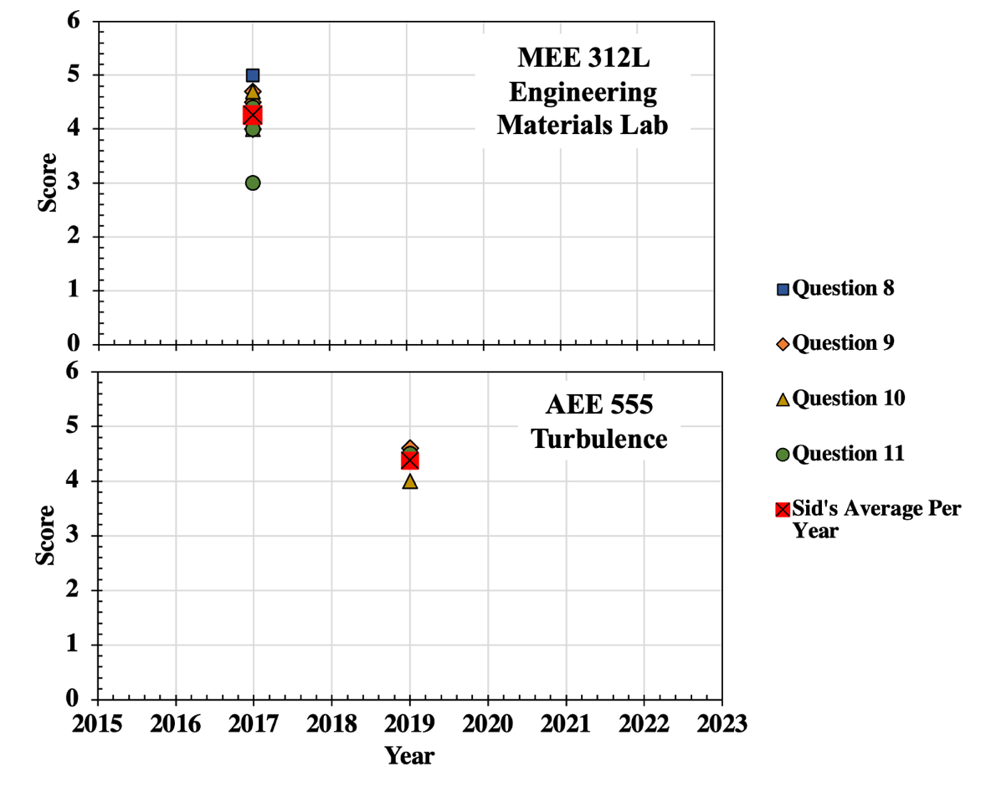
Figure 7. 10 SET scores from a) MEE 312L Materials Lab and b) AEE 555 Turbulence
Faculty Self-Evaluation:
Demonstrated Leadership
Comments:
As evidenced above, since 2016, I have taught around 9 different courses ranging from sophomore to graduate students. Creating and delivering new courses takes a significant amount of time but my intention was to help our department and our graduate students by teaching courses that are instrumental to the undergraduate and graduate aerospace program at UD. Apart from offering these many courses, I have also revamped 5 different courses to be offered in remote and hybrid style during the pandemic which took a lot of effort. I have also published three different ASEE papers and many of my modules are featured in UD blogpost and KEEN magazine. Due to these reasons, I self-evaluate myself as demonstrated leadership in this element.
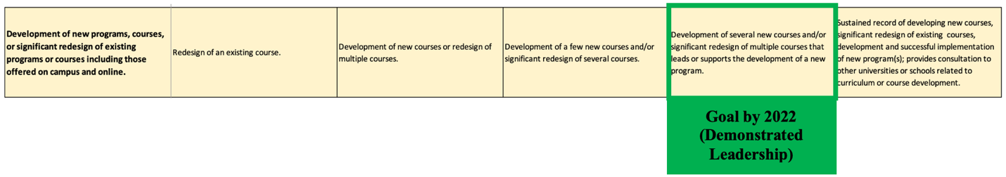
Department Faculty Development Committee Assessment (To be completed ONLY when the faculty member is going up for midterm or tenure and/or promotion review)
Choose an item.
Comments (optional):

Department Chair Assessment:
Choose an item.
Comments (optional):

School of Engineering Faculty Development Committee (To be completed ONLY when the faculty member is going up for midterm or tenure and/or promotion review)
Choose an item.
Comments (optional):

Associate Dean for Faculty and Staff Development:
Choose an item.
Comments (optional):

Elected Element 2: Developing and facilitating project, problem, inquiry and entrepreneurial based learning activities in existing courses.

List of Activities or Evidence to support progress for this Element:

Criteria 1: Consistent implementation of project, problem, inquiry and entrepreneurial based learning activities.

I routinely employ project, problem, inquiry, and entrepreneurially minded learning in all my courses. In the sections below, I describe how I employ these different techniques in my courses and provide evidence to support the discussion via cards created on Engineering Unleashed.com. To see the cards, faculty login on Engineering Unleashed.com is required since the cards are not accessible to students.

1. Problem-based learning

MEE 401/AEE 501 Aerodynamics
While teaching concepts such as vorticity, circulation, panel methods, etc. I employ a problem-based learning where I give students a real-world data from my Ph.D. and research and have them parse the data, determine how to apply the concepts to the data and obtain results that are meaningful and add value. I also use real world aircraft developed through theoretical aerodynamics such as Spitfire and Prandtl-D to teach concepts such as thin airfoil and lifting line theories. I have shared the data and the concepts with other faculty members and in the entire KEEN network in the KEEN cards below.

- Gunasekaran, S. Week 5 - The Role of Vorticity in Determining Aerodynamic Forces. Engineering Unleashed. Retrieved June 18, 2022, from https://engineeringunleashed.com/card/2741
- Gunasekaran, S. Week 10 - Lifting Line Theory: The Theory that Gave us the Supermarine Spitfire and Many More. Engineering Unleashed. Retrieved June 18, 2022, from https://engineeringunleashed.com/card/2756
- Gunasekaran, S. Week 11 - Case Study: Aerodynamics of Prandtl-D Wing - The Aircraft that Generates Induced Thrust. Engineering Unleashed. Retrieved June 18, 2022, from https://engineeringunleashed.com/card/2763

AEE 553 Compressible Flow
Similar to MEE 401 aerodynamics, while teaching concepts such as normal, oblique shocks, Fanno, Rayleigh flows, and Prandtl-Meyer flows, I start the topic with a real-world problem involving aircraft such as F-16, X-15, NASA’s Space Shuttle Main Engines (SSME’s), Turbine-less ducted fan, etc. and with real world data and have students work on applying the concepts, make assumptions, and obtain meaningful results. I have shared the data and the concepts with other faculty members and in the entire KEEN network in the KEEN cards below.

- Gunasekaran, S. Week 9 - Rayleigh Flow (Flow with Heat Addition) with NASA's Turbine-less Ducted Fan. Engineering Unleashed. Retrieved June 18, 2022, from https://engineeringunleashed.com/card/2524
- Gunasekaran, S. Week 10 - Fanno Flow and the Role it Plays in the Transport of the Natural Gas across the Country. Engineering Unleashed. Retrieved June 18, 2022, from https://engineeringunleashed.com/card/2525

MEE 225 Intro to Flight
It is very important when dealing with sophomore level students to engage them in the subject matter in a hands-on and open-ended approach so that they are well prepared for the higher-level aero courses offered at UD. As such, when teaching concepts such as glide ratio, coefficient of lift, drag, and aircraft performance, I always pose a real-world problem involving air crash investigations and have them make assumptions, figure out how to apply the concepts they learned in class to the problem and perform sanity checks on the results they get. One such module involving open ended and problem-based learning is shared in the exemplar Engineering Unleashed card in the link below.
- Gunasekaran, S., & Melton, D. Why do jets fly so high? Intro to thrust and Jet Engine Design. Engineering Unleashed. Retrieved June 18, 2022, from https://engineeringunleashed.com/card/763

2. Project-Based Learning

MEE 401/AEE 501 Aerodynamics
Applications of aerodynamics are vast and not just confined to aircraft. As such, I employ project-based learning in aerodynamics where students work on projects involving wind turbines, insects, trees, automobiles, sail boats, etc. where students study the aerodynamics and perform analysis and experimentation on these applications and applications of their interest. Students also get to work with the state-of-the-art UD wind tunnel, water tunnel, and the Merlin Flight Simulator as a part of the course. The videos of students’ passion projects can be found in the following link:

- Gunasekaran, S. (2017, April 24). MEE 401 Fundamental Aerodynamics Passion Projects. YouTube. Retrieved June 18, 2022, from https://www.youtube.com/watch?v=qcAkG5fuyE8&amp;t=1s

I also introduced on-going research projects as passion projects where each student team select a wing configuration to investigate numerically and experimentally. This is shown in the video below:
- Gunasekaran, S. (2018, May 16). Aerodynamics Spring 2018 - Passion Projects. YouTube. Retrieved June 18, 2022, from https://www.youtube.com/watch?v=BgBvitqANoM
An article on the use of passion projects can be seen in the link below –

- Garrow, K. New classroom approach brings passion to the forefront of learning: University of Dayton, Ohio. Retrieved June 18, 2022, from https://bit.ly/PassionProjectMEE401

AEE 590 Experimental Aerodynamics
Experimental aerodynamics is all about learning the design and operation of wind tunnels and the equipment used in the wind tunnels for flow diagnostics. The entire course was designed to be around project-based learning where each semester, students work on a total of 7 projects. For the wind tunnel design project, real-world requirements and constraints from AFRL and HRI company was given to the students and they need to present their design to the “customer”. This module is shared in the KEEN card below –

- Gunasekaran, S. Approaching Wind Tunnel Design with 3C’s. Engineering Unleashed. Retrieved June 18, 2022, from https://engineeringunleashed.com/card/867

MEE 225 Intro to Flight
A major revision to the introduction to flight course was made in 2020 to include a significant hands-on approach to learning about flight. Students got to design, build, fly, and analyze a RC aircraft as a part of the course where they learned the basic concepts through the lens of the airplane they were building and constantly apply the concepts to their aircraft to see tangible changes in the performance of the aircraft. It also allowed them to learn about flight controls and electronics required for the RC aircraft operation. An article on the revamped MEE 225 Intro to Flight course is included in the link below –

- Updyke, K. (June 10, 2021). When passion takes flight. University of Dayton, Ohio. Retrieved June 18, 2022, from https://bit.ly/WhenPassionTakesFlight

MEE 425 Aircraft Design
Aircraft design is one of the most important design courses in the aerospace curriculum where students get to design an aircraft and simulate it in the University of Dayton Merlin Flight Simulator. The entire course is structured to be project-based where each project is connected leading to a conceptual design of an aircraft. Moreover, towards the end of the course, students get feedback from test pilots and flight engineers from Wright Patterson Air Force Base and Society of Experimental Test Pilots (SETP) who gives one-on-one feedback to the students on their design. This is a one-of-a-kind experience which no other students get to experience in this context. An article on the use of Merlin Flight Simulator in the design course is included in the link below –

- Merlin Flight Simulator Lab. Curriculum : University of Dayton, Ohio. Retrieved June 18, 2022, from https://bit.ly/MerlinFlightSimulator

3. Entrepreneurially Minded Learning

I regularly employ Entrepreneurially Minded Learning in all of my courses. I firmly believe that students’ skillset and mindset should be developed in tandem as opposed to focusing on only the skillset. To demonstrate what an entrepreneurial mindset is, I employ the following module in the first day of all my courses to demonstrate the importance of EM mindset –
- Gunasekaran, S. Intro to EM in 2 Minutes. Engineering Unleashed. Retrieved June 18, 2022, from https://engineeringunleashed.com/card/863
This module was also used by a faculty member at the Montana State University as evidenced by the comments under the card.

The use of EML and focus on the mindset in my courses is shown in the article below -
- Our Competitive Edge : University of Dayton, Ohio. Retrieved June 18, 2022, from https://bit.ly/EMLatUD

MEE 225 Introduction to Flight
Intro to flight course is the first-time students learn the basics of flight and decide whether or not they want to pursue aerospace engineering as their career. As such, it is important to expose students to the 3C’s (curiosity, connections, and value creation) in this course so that students can make an informed decision whether or not to pursue a career in aerospace engineering. I employ 3C’s when throughout the entirety of the course but a notable one is the module on conservation laws – conservation of mass and momentum in the context of thrust production. This EML approach to teaching conservation laws from my intro to flight course is published in the 2017 KEENzine magazine:

- Gunasekaran, Sidaard and Doug Melton. “Getting EML Off the Ground: Why Do Jets Fly So High?”. KEEN Magazine, p 08. 2017 (https://engineeringunleashed.com/keenzine5/10/)

MEE 401/AEE 501 Aerodynamics
Similar to intro to flight course, I employ EML in almost all classes in my aerodynamics class. I employ techniques such as QFT (question formulation technique), Think-pair-share, Gallery walk, etc. to engage students in EM oriented questions related to the topic that was covered in the course. The weekly modules and the corresponding EML activities and modules are published in the following cards in the Engineering Unleashed platform:

- Gunasekaran, S. Week 1 - Flowlines: A way to Reveal the Invisible. Engineering Unleashed. Retrieved June 18, 2022, from https://engineeringunleashed.com/card/2714
- Gunasekaran, S. Week 2 - Connecting Model Geometry to Forces and a First Look at the Power of Non-Dimensionalization. Engineering Unleashed. Retrieved June 18, 2022, from https://engineeringunleashed.com/card/2717
- Gunasekaran, S. Week 3 - Joukowski Transformation: A Tool to Design Airfoils. Engineering Unleashed. Retrieved June 18, 2022, from https://engineeringunleashed.com/card/2725
- Gunasekaran, S. Week 4 - Estimating Aerodynamic Forces from Governing Equations of Fluid Dynamics. Engineering Unleashed. Retrieved June 18, 2022, from https://engineeringunleashed.com/card/2740
- Gunasekaran, S. Week 5 - The Role of Vorticity in Determining Aerodynamic Forces. Engineering Unleashed. Retrieved June 18, 2022, from https://engineeringunleashed.com/card/2741
- Gunasekaran, S. Week 6 - Circulation: A Revolutionary Concept in Aerodynamics. Engineering Unleashed. Retrieved June 18, 2022, from https://engineeringunleashed.com/card/2746
- Gunasekaran, S. Week 7 - Elementary Flows: Building blocks for Simple Flow Simulation). Engineering Unleashed. Retrieved June 18, 2022, from https://engineeringunleashed.com/card/2748
- Gunasekaran, S. Week 8 - Kutta Condition and Simulating Flow over Joukowski Airfoil. Engineering Unleashed. Retrieved June 18, 2022, from https://engineeringunleashed.com/card/2750
- Gunasekaran, S. Week 9 - Thin Airfoil Theory: The Most Revered Theory in all of Aerodynamics. Engineering Unleashed. Retrieved June 18, 2022, from https://engineeringunleashed.com/card/2752
- Gunasekaran, S. Week 10 - Lifting Line Theory: The Theory that Gave us the Supermarine Spitfire and Many More. Engineering Unleashed. Retrieved June 18, 2022, from https://engineeringunleashed.com/card/2756
- Gunasekaran, S. Week 11 - Case Study: Aerodynamics of Prandtl-D Wing - The Aircraft that Generates Induced Thrust. Engineering Unleashed. Retrieved June 18, 2022, from https://engineeringunleashed.com/card/2763

AEE 553 Compressible Flow
Similar to aerodynamics course, I routinely employ active learning techniques to foster EML in my compressible flow course. Initially, this course was heavily derivation based. Upon multiple iterations, this course happened to be my students’ most favorite course that I have taught. The concepts are so elegant and presents a cohesive story that the EM components fits in well. The EM modules developed for this course is shared in the Engineering Unleashed.com as shown in the links below.

- Gunasekaran, S. Week 1 - Reynolds Transport Theorem: Insight into Conservation of... well, anything!. Engineering Unleashed. Retrieved June 18, 2022, from https://engineeringunleashed.com/card/2513
- Gunasekaran, S. Week 2 - What is the Role of Thermodynamics in Compressible Flow?. Engineering Unleashed. Retrieved June 18, 2022, from https://engineeringunleashed.com/card/2515
- Gunasekaran, S. Week 3 - A Mind Bending Relationship between Area and Flow Speed. Engineering Unleashed. Retrieved June 18, 2022, from https://engineeringunleashed.com/card/2516
- Gunasekaran, S. Week 4 - The Role of Back Pressure. Engineering Unleashed. Retrieved June 18, 2022, from https://engineeringunleashed.com/card/2517
- Gunasekaran, S. Week 5 - The What, How and the Why of Shock Waves. Engineering Unleashed. Retrieved June 18, 2022, from https://engineeringunleashed.com/card/2518
- Gunasekaran, S. Week 6 - What do Supersonic Engine Inlets and Supersonic Wind Tunnels have in Common? - The Oblique Shocks. Engineering Unleashed. Retrieved June 18, 2022, from https://engineeringunleashed.com/card/2519
- Gunasekaran, S. Week 7 - A Look Into Detached Shocks (An Interactive Approach). Engineering Unleashed. Retrieved June 18, 2022, from https://engineeringunleashed.com/card/2521
- Gunasekaran, S. Week 8 - Prandtl Meyer Flow + Bonus Material (Connection between Water Flow and Shock Waves). Engineering Unleashed. Retrieved June 18, 2022, from https://engineeringunleashed.com/card/2523
- Gunasekaran, S. Week 9 - Rayleigh Flow (Flow with Heat Addition) with NASA's Turbine-less Ducted Fan. Engineering Unleashed. Retrieved June 18, 2022, from https://engineeringunleashed.com/card/2524
- Gunasekaran, S. Week 10 - Fanno Flow and the Role it Plays in the Transport of the Natural Gas across the Country. Engineering Unleashed. Retrieved June 18, 2022, from https://engineeringunleashed.com/card/2525
- Gunasekaran, S. Week 11 - Linearized Flow (Method of Small Perturbations for Subsonic and Supersonic Flows). Engineering Unleashed. Retrieved June 18, 2022, from https://engineeringunleashed.com/card/2526

MEE 425 Aircraft Design
The entire aircraft design course is scaffolded into multiple projects so the results from one project can be used in the next finally leading to legit conceptual aircraft design that performs as expected. Since students drive the project forward to make progress, the EM component was able to be integrated into the course without significant changes to the overall structure of the course. The primary EM component are the QFT (question formulation technique) that forces students to be curious to think outside the box, make connections from one topic to the next, and find value in their design and their approach to design. These modules are discussed in the following KEEN cards:

- Gunasekaran, S. Week 1 - 2 Introduction and Review of Aircraft Performance. Engineering Unleashed. Retrieved June 18, 2022, from https://engineeringunleashed.com/card/2852
- Gunasekaran, S. Week 3 - 4 Finding the Niche Through Historical Buildup. Engineering Unleashed. Retrieved June 18, 2022, from https://engineeringunleashed.com/card/2853
- Gunasekaran, S. Week 5 - 6 Takeoff Weight Buildup and Constraints. Engineering Unleashed. Retrieved June 18, 2022, from https://engineeringunleashed.com/card/2854
- Gunasekaran, S. Week 7 - 8 Configuration Selection, Initial Sizing, and 3D Modeling. Engineering Unleashed. Retrieved June 18, 2022, from https://engineeringunleashed.com/card/2855
- Gunasekaran, S. Week 9 - 10 Component Level Weight Estimation, VN Diagram, CG Calculations. Engineering Unleashed. Retrieved June 18, 2022, from https://engineeringunleashed.com/card/2856
- Gunasekaran, S. Week 11 - 12 Aerodynamic Buildup and Drag Estimations. Engineering Unleashed. Retrieved June 18, 2022, from https://engineeringunleashed.com/card/2857
- Gunasekaran, S. Week 13 - 14 Aircraft Performance Evaluation. Engineering Unleashed. Retrieved June 18, 2022, from https://engineeringunleashed.com/card/2858

4. Inquiry Based Learning
Inquiry based learning is an integral part of problem-based, project-based, and entrepreneurial minded learning. However, I strongly focus on inquiry-based learning using portfolios as a means of assessment. Portfolio writing in technical courses such as the ones mentioned above forces students to perform significant inquiry to search for pictures, tables, graphs, etc. to support their narrative. Portfolio also provides a platform to assess EML where students’ curiosity, connections, and value creation becomes transparent. The use of portfolios in assessing EML is discussed in the 2017 KEEN Magazine article –

- Gunasekaran, Sidaard and Doug Melton. “Getting EML Off the Ground: Why Do Jets Fly So High?”. KEEN Magazine, p 08. 2017 (https://engineeringunleashed.com/keenzine5/10/)

Criteria 2: Effective mentoring of other faculty in these pedagogical practices

One of the major reasons behind creating all the KEEN cards mentioned above is to share my teaching modules, ideas, and techniques to other faculty at UD and to faculty members in other institutions. I have shared my pedagogical practices through cards, papers, workshops, and panels. I have shared all the modules that I developed for compressible flow with Dr. Carson Running who is currently teaching the course and coached him on the use of portfolios. I have shared the modules I developed for aerodynamics with adjunct faculty members such as Dr. Jose Camberos, Dr. Michael Ol, and Dr. Kasim Biber who is currently employing some of the real-word problem-based and project-based learning that I developed. I also have shared the EML modules that I developed for Engineering Materials to Dr. Robert Lowe.

I have shared the EML modules that I developed to new faculty in 2021 and 2022 KEEN Fellows meeting and to faculty in the Teaching Forum. I have also shared the modules that I developed to faculty in the following institutions as a part of KEEN Ambassador program –

- Valparaiso University
- George Washington University
- Drexel University
- Florida Gulf Coast University
- Duke University
- Michigan Tech University
- Rochester Institute of Technology
- Clarkson University
- Tulane University
As a Studio Fellow, I have shared the use of modern classroom technology and its integration into modern pedagogical practices through the following flyer podcast –

- Curran, A. A Look Inside the LTC studio with Dr. Sidaard Gunasekaran. Listen Notes. Retrieved June 18, 2022, from https://bit.ly/TeachinginLTCStudio

As an Institute of Applied Creativity for Transformation (IACT) fellow, I have shared the use of Ideation, Disruption, and Aha (IDA) pedagogy in the MEE 225 Introduction to Flight course through the following ASEE paper:

- Gunasekaran, Sidaard. "Using Ideation, Disruption, Aha (IDA) Pedagogy in Introduction to Flight." ASEE Annual Conference and Exposition. 2019. https://peer.asee.org/25203

The practice of using portfolios to assess 3C’s in my courses is also shared in the KEEN stories –

- KEEN Network (2019, March 14). How do you measure a mindset? | Sid Gunasekaran. YouTube. Retrieved June 18, 2022, from https://bit.ly/MeasuringMindset

Criteria 3: Use of continuous improvement strategies for inset list

1. Reducing time required for writing and reviewing portfolios
Portfolio-based learning and assessment has significant impact on students learning when compared to traditional exam-based approach. The following ASEE paper was written on the Integrated Teaching Model using portfolio as a platform to make students’ thinking visible and assess their 3C’s. The link to the paper is shown below –
- Gunasekaran, Sidaard. "Integrated Teaching Model in Graduate Aerospace Classes: A Trial with Compressible Flow Aerodynamics." ASEE Annual Conference and Exposition. 2017. https://doi.org/10.18260/1-2--28546

However, one of the major drawbacks in the model is the time invested by students and me to write and review portfolios. This was addressed in the following ASEE paper by scaffolding the portfolio writing process:
- Gunasekaran, Sidaard. "Integrated Teaching Model: A Follow Up with Fundamental Aerodynamics." ASEE Annual Conference and Exposition. 2018. https://doi.org/10.18260/1-2--30677

The scaffolded approach reduced the time required by the students to structure and organize the portfolio without compromising the focus on the content and the 3C’s.

2. Use of Guided Notes in Classrooms
Most of the courses mentioned above are heavily math and derivation oriented. While it is important to go through the derivation process, students don’t get any benefit by copying the equations directly from the board. As such, I started using guided notes in my classroom where the derivations are printed out in a paper with key variables and steps missing. Students get to fill in the missing steps and variables through active engagement and interaction with other students in class. This made an effective means to go through the derivation much faster without compromising the rigor and the synthesis of the content. The use of guided notes in my courses is discussed in the following video along with a student testimony –

Gunasekaran, S. (2020, July 27). The Use of Guided Notes in Classroom YouTube. Retrieved June 18, 2022, from https://www.youtube.com/watch?v=C5IxNhOGhKY

3. Including 3C’s and Bloom’s Taxonomy in the Course Syllabus
It is very important that students are aware of the class expectations early in the course that they are expected to reach higher levels of Bloom’s taxonomy and incorporate EML into their learning process. As such, the syllabus for all my courses contains a detailed explanation of what Bloom’s taxonomy is and how EML will be incorporated into the course. This was very helpful in setting the tone for the course and managing student expectations.

Criteria 4: Development of tools, resources, etc. to facilitate implementation (online content, handouts, grading rubrics, etc.)

1. Online Content and Leveraging Isidore for Remote/Hybrid Learning
Significant online content was developed during the pandemic for the following courses:
- MEE 225 Introduction to Flight
- MEE 401 Aerodynamics
- MEE 425 Aircraft Design
- AEE 553 Compressible Flow
- AEE 501 Aerodynamics
- AEE 590 Experimental Aerodynamics

Isidore lesson page was heavy leveraged to share and conduct remote learning effectively during the pandemic. An example Isidore page from my introduction to flight course can be found in the link below - Isidore : 21_SP_FT_MEE_225_01 : Lessons (udayton.edu)

2. Using Custom Developed MATLAB Apps in Classrooms
There are lot of studies that have shown that interactive approach is the one of the best ways for students to learn the concept. As such, I constantly write programs to convey a complicated concept in an interactive way so that students can understand the topic by themselves and perform sensitivity analysis that fosters synthesis and evaluation of the topic.

In AEE 553 Compressible Flow, to demonstrate the concept of Busemann Shock Polar, I wrote the following Matlab App for students to learn the topic through interactive sessions.

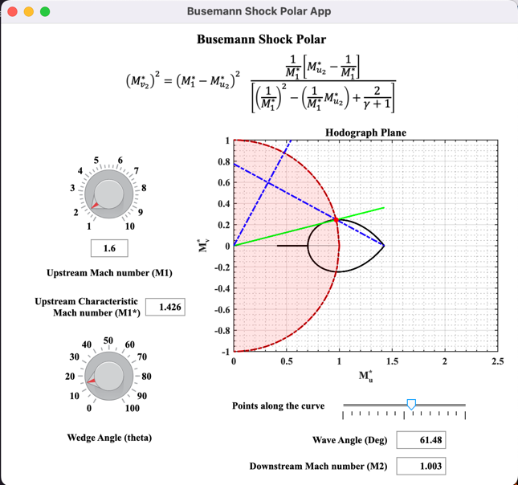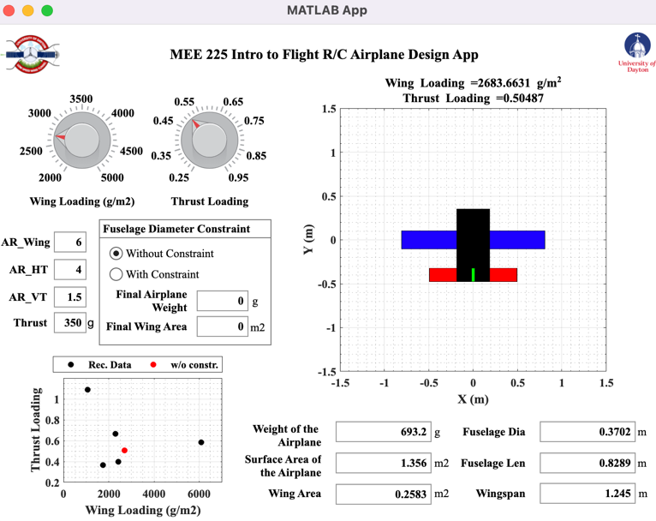

Figure 8.1 MATLAB Apps written for interactive sessions with students in class

In MEE 225 Introduction to Flight, I wrote the following app for students to perform sensitivity study on the role of wing loading and thrust loading in aircraft size.

3. Developing Rubrics
Significant amount of time is dedicated to developing rubrics for grading portfolios in all the courses mentioned above. Isidore’s rubric option was heavily leveraged during the pandemic. Few examples of rubrics developed is shown in the link below –

https://drive.google.com/drive/folders/1lU4fV99Phsn5QEVT1093WpMfeLDNobvz?usp=sharing

Faculty Self-Evaluation:
Demonstrated Leadership
Comments: As evidenced above, I have employed numerous problem-based learning, project-based learning, inquiry-based learning through the use of portfolios, and entrepreneurial minded learning in all my courses. I have published more than 30 different KEEN cards on EngineeringUnleashed.com based on the problem-based, project-based, and entrepreneurial minded learning. I have also developed significant online content and interactive tools for the students to get engaged in classrooms. I have also shared my pedagogies and modules with faculty from our institution as well as institutions across the nation through the KEEN network. Some of my modules are adopted by faculty in other institutions as well. For these reasons, I self-evaluate myself as demonstrated leadership in this element.
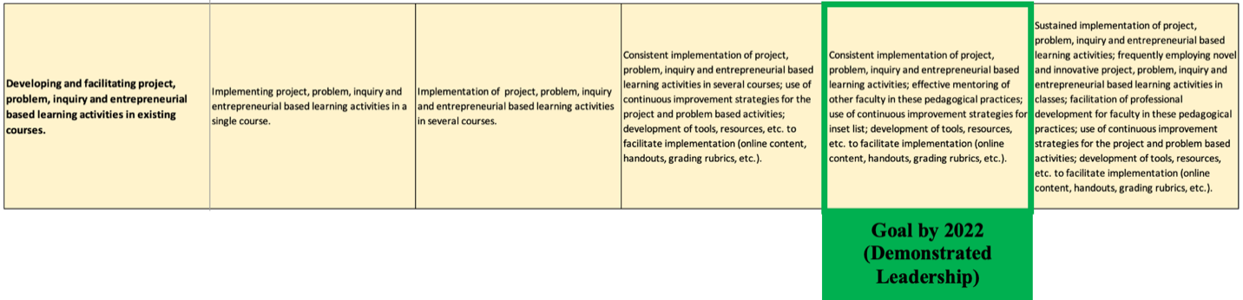

Department Faculty Development Committee Assessment (To be completed ONLY when the faculty member is going up for midterm or tenure and/or promotion review)
Choose an item.
Comments (optional):

Department Chair Assessment:
Choose an item.
Comments (optional):

School of Engineering Faculty Development Committee (To be completed ONLY when the faculty member is going up for midterm or tenure and/or promotion review)
Choose an item.
Comments (optional):

Associate Dean for Faculty and Staff Development:
Choose an item.
Comments (optional):

Elected Element 3: Advising student clubs, organizations and competition teams.

List of Activities or Evidence to support progress for this Element.

Criteria 1: Multi-year commitment as the formal adviser to a team or club that includes active engagement with the students, promotion of the team or club, and its students that may include travel to competitions or conferences

I have been serving as the primary advisor to the following aero related clubs at UD:

1. Design Build Fly (DBF) Club

As an advisor for this club, I teach students how to design, build, and fly RC airplanes for various missions. Every year, the team designs a RC aircraft to compete in competitions such as Speed fest, Solar powered aircraft competition, etc.

In 2017, the team built RC airplane powered by RC Internal combustion engine.

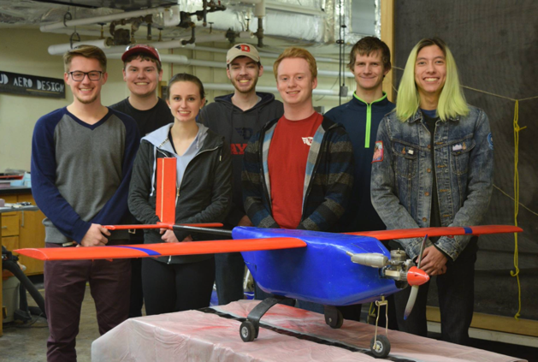
Figure 9.1 2017 DBF Student Team
In 2018, the team built a solar powered aircraft and won 1st place in the OSGC sponsored solar powered aircraft competition held in Dayton.
- May 2018 UAS Competition - OSGC UAS. Google Sites: Sign-in. Retrieved June 18, 2022, from https://sites.google.com/site/osgcstars/home/competitions

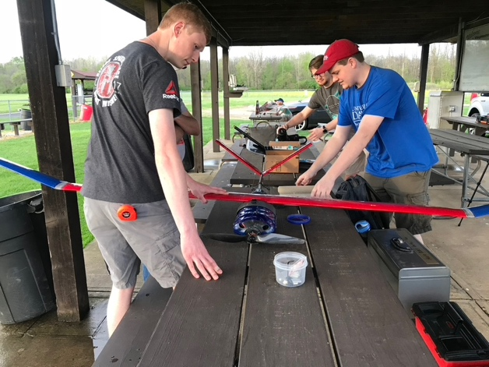
Figure 9.2 2018 DBF Student Team
In 2019, the team built the first ever jet engine propelled RC aircraft at UD and participated in speedfest competition.

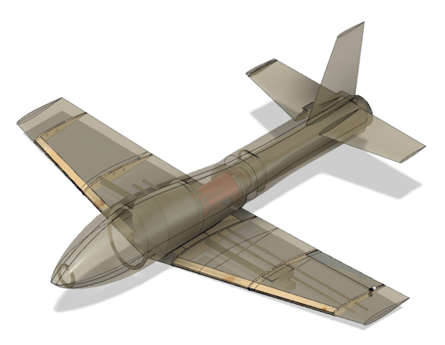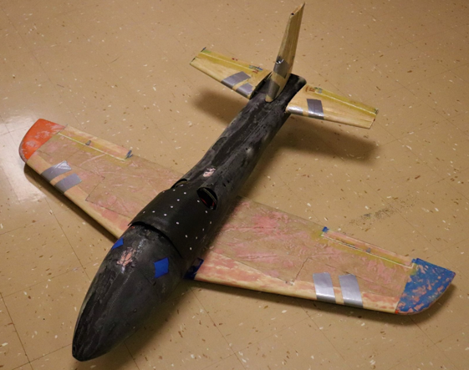
Figure 9.3 First even RC jet Aircraft built at UD by 2019 DBF Student Team

In 2020, due to the pandemic the team did not build any aircraft but I taught the students how to build foam board airplanes as shown in the pictures below.

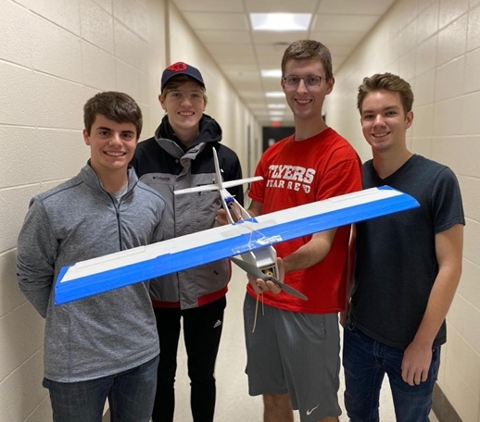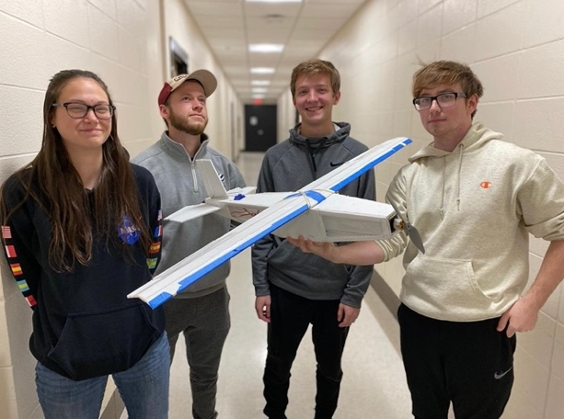
Figure 9.4 DBF student team designed, built, and flew foam board airplanes
In 2021, the team couldn’t get access to the DBF room due to pandemic restrictions and as such it did not create an airplane.

In 2022, the team designed the following aircraft but didn’t have enough manpower to finish building it. However, the team once again designed, built, and flew foam board airplanes.

2. IT Flies Club

As an advisor for the IT Flies competition, I guided students to put aircraft model in the flight sim and participate in the annual IT Flies competition.

2018 IT Flies competition
- YouTube. (2018, May 18). It flies competition 2018 Slideshow - University of Dayton. YouTube. Retrieved June 18, 2022, from https://www.youtube.com/watch?v=6D7UezMD92k&t=87s
2019 IT Flies competition
- YouTube. (2019, April 18). It flies competition 2019 Slideshow - University of Dayton. YouTube. Retrieved June 18, 2022, from https://www.youtube.com/watch?v=s4qkH90wGBk&t=4s
2021 IT Flies competition
- IT Flies! Merlin Flight Competition. Merlin Flight Simulator Competition : University of Dayton, Ohio. (n.d.). Retrieved June 18, 2022, from https://udayton.edu/engineering/departments/mechanical_and_aerospace/it-flies.php
2022 IT Flies competition
Updyke, K. University of Dayton Team Takes First Place at It Flies International Flight Simulation Competition. University of Dayton team takes first place at IT Flies international flight simulation competition : University of Dayton, Ohio. Retrieved June 18, 2022, from https://udayton.edu/blogs/engineering/2022/22-05-23-itflies.php

Please see letter of support from Chris Neal and Marion about my role in the IT Flies club and running the flight simulator.

3. UD AIAA Club

As an advisor for the UD AIAA (American Institute of Aeronautics and Astronautics) club, I help students organize dinner meeting with a guest speaker for the local AIAA chapter and help design aero related applications such as drones and 3D printed supersonic wind tunnel.

Fall 2016 – Hosted Mr. Eugene Fleeman to UD to speak about Missile Design, Development and System Engineering
Fall 2017 – Hosted Mr. Tom Morgenfeld, the X-35 Test pilot to UD to speak about Development of the X-35 prototype and Test Flight. Below is a picture during the event.

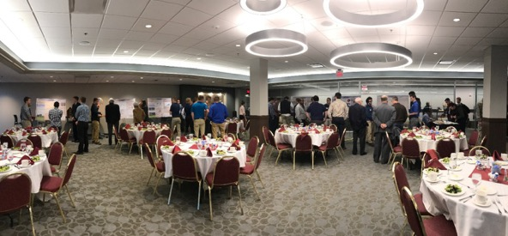

Spring 2018 – Assisted local chapter with dinner meeting with Mr. Kenneth Szalai as a guest speaker to speak about Flights of Discovery – Impact and Lessons from Experimetnal Flight Research at NASA Neil Armstrong Flight Research Center at the Four Bridges Country Club.

Spring 2019 – Hosted Mrs. Michelle Evans, the author of X-15 Rocket plane to UD to talk about the X-15 rocket plane, flying the first wings to space. Below are some pictures from the event

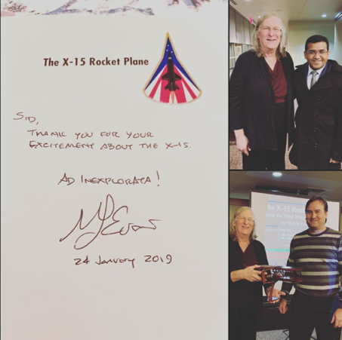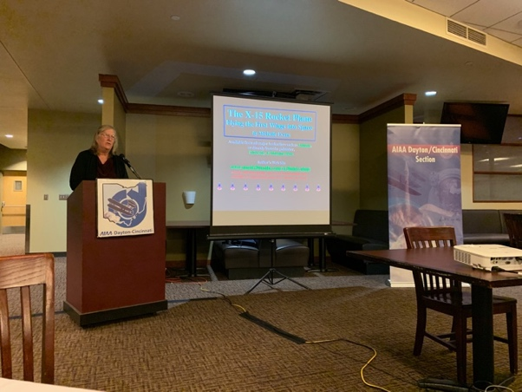

Fall 2019 – Hosted Mr. Pradeep Raj to UD to talk about Applied Computational Aerodynamics (ACA), Reflections on Long and Exciting Journey in the never-ending pursuit of effectiveness

No events were held in 2020 and 2021 due to pandemic. However, in 2020 and 2021, the club designed, 3D printed, and tested the first ever 3D printed supersonic wind tunnel. The results were presented in the 2020 annual Dayton-Cincinnati Annual Student Science Symposium (DCASS) and published in the 2020 SCITECH conference.

Spring 2022 – Hosted Mr. Walter Gordon to UD to talk about Project Gemini: Unsung Hero of Neil’s Armstrong’s One Small Step

The hyperlinks serve as evidence of above-mentioned club activities.

In Spring 2022, due to interest from several students, I, along with Dr. Andrew Sarangan, chair of the electro-optics department started the UD Aviation Club for those students who are interested in learning to fly. We both are currently co-advising the club.

Criteria 2: Helping with fund raising

1. For DBF Club
Apart from helping the club secure SGA funding, the following funds/equipment were also obtained through alumni or through donation –

- K30 Jet Engine was donated by KingTech to the club that is worth $1,590. The picture below serves as evidence of the funds obtained.
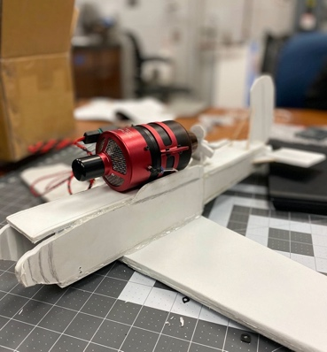
Figure 9.5 Jet engine donated by KingTech to the UD DBF club

2. For UD AIAA Club
Apart from helping the club secure SGA funding, the following funds/equipment were also obtained through alumni or through donation –

- $500 – from local AIAA chapter for student travel to SCITECH conference
- 3D printed Ultem 1010 material for the supersonic wind tunnel worth $5000 was donated to the UD AIAA club from AFRL RQH High Speed Systems Division. The picture below serves as evidence of the funds obtained.
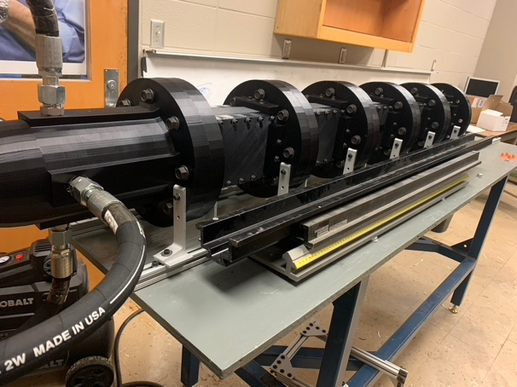
Figure 9.6 Fully 3D printed supersonic wind tunnel with materials donated by AFRL RQH High Speed Systems Division

Criteria 3: Recognition through regional publications, awards, and honors.

1. In 2018, the DBF team won 1st price in OSGC sponsored solar powered aircraft competition.

- May 2018 UAS Competition - OSGC UAS. Google Sites: Sign-in. Retrieved June 18, 2022, from https://sites.google.com/site/osgcstars/home/competitions

2. In 2018, Will Cammack from UD IT Flies team won first place in the 2018 IT Flies competition

3. In 2019, Michael Mongin and Rachel Supina from UD IT Flies team won the best presenation for the 2019 UK IT Flies competition

4. In 2019, Andrew Killian and Ryan Simkins from the UD IT Flies team first place in the 2019 IT Flies competition

5. In 2021, Calvin Callahan and Jacob Montgomery won 2nd place in the 2020 Virtual IT Flies competition

6. In 2022, Andrew Killian, Luke Duncan and Mauricio Hernandez from the UD IT Flies team won first place in the IT Flies 2022 competition

7. In 2022, Colin Fletcher and Andrew Killian from the UD IT Flies team won the best presentation in the IT Flies 2022 competition

Faculty Self-Evaluation:
Demonstrated Leadership
Comments:
As evidenced above, I have been mentoring three different aerospace related student clubs at UD for the past several years. I have advised students teams in DBF club and IT Flies club where our UD students have won several national level competitions as mentioned above. I have also raised funds for the DBF club and the AIAA club for equipment. I have also helped organize several IT Flies competitions and AIAA dinner meetings at UD that brought several aerospace professionals and distinguished speakers to meet and interact with our students. For these reasons, I self-evaluate myself as demonstrated leadership in this element.
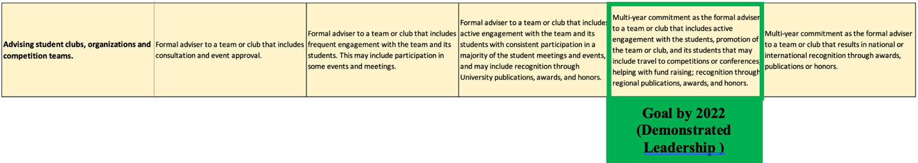
Department Faculty Development Committee Assessment (To be completed ONLY when the faculty member is going up for midterm or tenure and/or promotion review)
Choose an item.
Comments (optional):

Department Chair Assessment:
Choose an item.
Comments (optional):

School of Engineering Faculty Development Committee (To be completed ONLY when the faculty member is going up for midterm or tenure and/or promotion review)
Choose an item.
Comments (optional):

Associate Dean for Faculty and Staff Development:
Choose an item.
Comments (optional):

Broader Impact Element: International, regional or local community service

List of Activities or Evidence to support progress for this Element.

Criteria 1: Sustained (participation for several semesters) participation in long-term service activities

A. Service as Director of Aerospace Labs

1. Director of the University of Dayton Low Speed Wind Tunnel (UD-LSWT) (Spring 2017 – Present)
University of Dayton Low Speed Wind Tunnel (UD-LSWT) has been the flagship laboratory for aerodynamic related teaching, research, and service activities in the Mechanical and Aerospace Engineering department for many years at UD. Historically, the UD Low speed wind tunnel (UD-LSWT) has served as a platform for various research activities as well as exposing students to the fundamentals of experimental aerodynamics throughout their undergraduate and graduate curriculum. UD-LSWT is an open jet wind tunnel with multiple adaptable test sections with a state-of-the-art shuttering system which allows it to modulate the frequency of freestream to perform unsteady aerodynamics and gust response type research on a small-scale aircraft and other aerodynamic models. UD-LSWT has been instrumental in various fundamental and applied research projects involving unconventional wing designs (slotted, contoured, iced, etc.), wake energy harvesting, wind turbines, wingtip vortices, propeller ground effects in hover/forward flight, wake shedding, morphing wing, etc. As the director of this lab, my responsibility is to accommodate AFRL/UDRI researchers, undergraduate and graduate research students, spray drift testing of industry clients, open houses, outreach activities, and aerospace course related experiments.

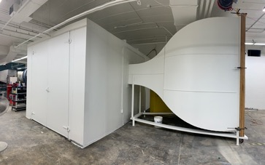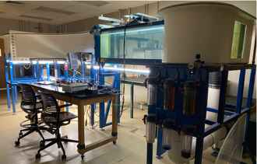
Figure 10.1 University of Dayton Wind Tunnel and Water Tunnel
2. Director of the University of Dayton Water Tunnel (UD-WaT) (Spring 2020 – Present)
University of Dayton Water Tunnel (UD-WaT) was established as one of the aerolabs in the department in Spring of 2020. The water tunnel offers a range of Reynolds number to test which is far below what the UD-LSWT can offer. Unlike the UD-LSWT, the water tunnel is predominantly a research facility established in collaboration with AFRL, and fitted with equipment to design, develop, and test closed loop control system architectures to mitigate unsteady and gust loads on wings. The closed loop control system developed in the lab allows for lift tracking and control over a range of reduced frequencies and amplitudes, especially when subjected to external discrete and periodic disturbances. It also allows testing of many of the existing unsteady models for its robustness and accuracy. As a director of this lab, my responsibility is to work with Dr. Albert Medina from AFRL/RQVA Aerodynamic Technologies to coordinate tools, equipment, and funding needed for closed loop control experiments at UD-WaT and to maintain equipment and train students to use the equipment.

3. Director of the Merlin Flight Simulator
The University of Dayton Merlin Flight Simulator is a one-of-a-kind engineering flight simulator in the country that can mimic the dynamics of any aircraft based on physics. It has been widely used in teaching in all levels of the aerospace curriculum from freshman to senior and graduate students as a platform for learning all about aircraft design, dynamics and performance. Moreover, through the aircraft design course and the annual IT Flies competition, students have their aircraft design judged by test pilots from Society of Experimental Test Pilots (SETP) which takes the experiential learning to another level! As a director of this lab, my responsibility is to hire student flight technicians, accommodate graduate and undergraduate students to work in sim, coordinate open houses, outreach activities, and aerospace course related work.

B. Outreach Activities

Summer 2017- Organized Aerospace Related Events for Minority Engineering and Technology Students
Fall 2017- Participated in Open Houses and Explore Engineering Activities
Summer 2018- Organized Aerospace Related Events for Minority Engineering and Technology Students
Fall 2018- Participated in Open Houses and Explore Engineering Activities
Summer 2019- Organized Aerospace Related Events for Minority Engineering and Technology Students
Fall 2019- Participated in Open Houses and Explore Engineering Activities
Summer 2020- Organized Aerospace Related Events for Minority Engineering and Technology Students
Fall 2020- Participated in Open Houses and Explore Engineering Activities
Summer 2021- Organized Aerospace Related Events for Minority Engineering and Technology Students
Summer 2021- Hosted Air Camp students with various wind tunnel, flight simulator, and glider building activity
Fall 2021- Participated in Open Houses and Explore Engineering Activities

C. Hosting US Air Camp at UD

The US Air Camp is one of the well-known Summer Air Camps across the country. UD used to host Air Camp in the past but in the mid-2010s due to lack of support, the air camps were not hosted at UD. In 2018, I along with Dr. Pinnell decided to bring back the tradition of hosting Air Camp students at UD throughout the summer. As a part of the Air Camp, I helped design modules in UD Wind tunnel and in the flight simulator. I also trained by students to facilitate some of the modules of the Air Camp. Figure 10.2 is presented as evidence of the service. I hosted US Air Camp at UD in the years of 2018, 2019, and 2021. 2020 US Air Camp was cancelled due to pandemic.

D. Professional and Local AIAA Community Service

As a member of American Institute of Aeronautics and Astronautics, I have served the greater community of Dayton through various outreach activities throughout several years. In late 2015, I was awarded the AIAA Chairman’s Award for Outstanding Support of the AIAA Dayton-Cincinnati Section K-12 STEM Outreach program. I have held outreach booths in the following events in Dayton since 2016:

- Dayton Air Show
- WACO Fly In
- Aero Carnival
- Techfest

The pictures below are presented as evidence of the service.

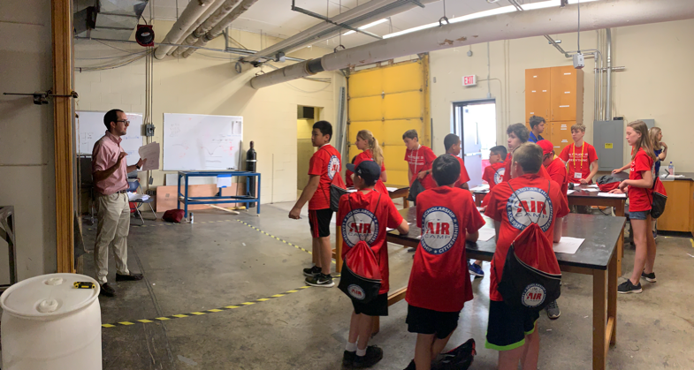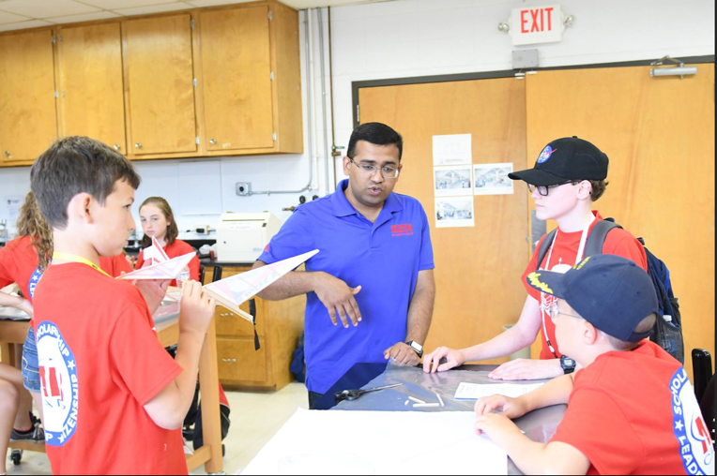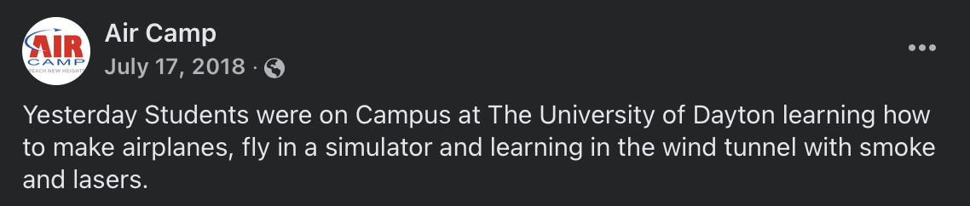
Figure 10.2 Hosting Air Camp Students at the University of Dayton for the past several years https://www.facebook.com/AirCampUSA/
“I respectfully offer that he (Sid) has consistently demonstrated a commitment to STEM Outreach on behalf of students across the nation within our organization. It is with great confidence that I share that he has served as a consistent and reliable leader in the field of engineering for participants who join us to explore viable career training opportunities during Air Camp Multi-day Overnight Events over the past several years. He has provided a uniquely exemplary amount of time, dedication, support, and flexibility to collaborations with our Curriculum Specialists to offer meaningful and immersive experiences in the field of Aeronautical Engineering to hundreds of students who wish to be exposed to sustainable, accessible, lucrative, and meaningful professional pathways in the fields of aviation and aeronautics whom we host from as many as 32 states each year.”
- Shannon Coblentz,
Air Camp, Inc. Director of Operations

Please see the rest of the letter of support from Shannon Coblentz in Tab 10 of my dossier.
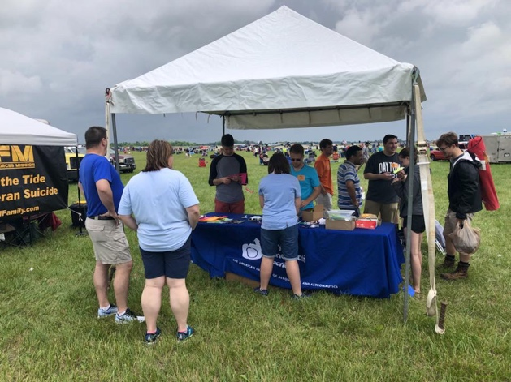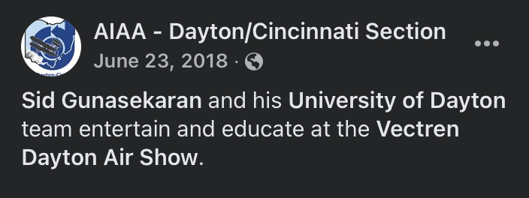
Figure 10.3 Held Outreach Events at the Dayton Air Show https://bit.ly/AIAAService
I am also serving as a reviewer for AIAA journal, Aerospace Science and Technology journal, MDPI Aerospace journal, and MDPI energies journal. Since 2019, I am serving as an auxiliary member in the executive committee in ASEE Aerospace division.

I have been selected to lead and organize the 2023 AIAA Region III Student Conference at the University of Dayton in March 2023.

E. KEEN Service

I have been serving the KEEN community and the network in variety of ways:

1. Community Catalyst (Spring 2018 – Spring 2020)
As a part of community catalyst, I have helped the development of Engineering Unleashed.com (EU.com) since its inception. I have trained several faculties from different institution in creation and adoption of cards from EU.com. Figure 10.4 is presented as evidence of this service.

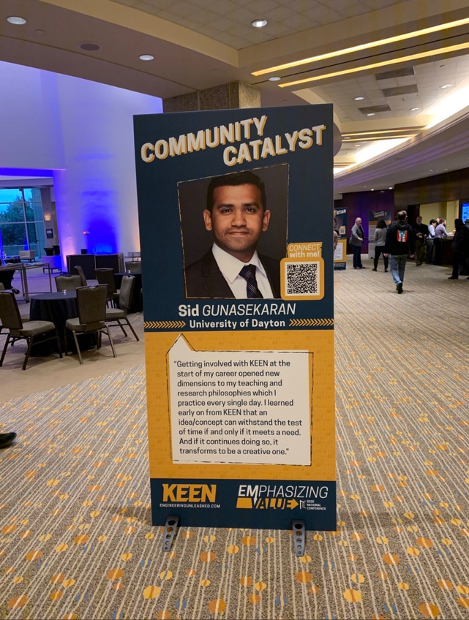
Figure 10.4 I was featured at the KEEN National Conference for my service as the Community Catalyst

2. Subnet Catalyst (Spring 2020)
As a part of Subnet Catalyst, I helped revamp the use of subnets in the EU.com. The subnets were then changed to groups in the new version of the EU.com

3. KEEN Ambassador (Spring 2019 – Spring 2020)
To kickstart the onboarding initiatives in the newly joined institutions in the KEEN network, I along with Dr. Ken Bloemer conducted the following events –

- Strategic Doing Workshop - A 2-hour workshop with 6-8 KEEN leaders driving the KEEN initiatives in respective institutions. The idea is to identify high impact and relatively easy to implement ideas to get KEEN initiatives moving forward.
- Overview of Kern Family Foundation and KEEN Network - This 1.5 hour session was open to all faculty and covers KEEN, entrepreneurially minded learning (EML) and modules that I have developed in my courses, demonstrating the EngineeringUnleashed.com platform and candid discussions about the entrepreneurially minded learning movement.
- Funding Opportunities - A 30 minute discussion with faculty to talk about funding opportunities.
- Facility Tour - An engineering facilities tour to potentially identify opportunities for KEEN initiatives.

The above-mentioned modules were conducted at the following 10 different institutions in-person:

- Valparaiso University
- George Washington University
- Drexel University
- Florida Gulf Coast University
- Duke University
- Michigan Tech University
- Rochester Institute of Technology
- Clarkson University
- Tulane University
- University of Toledo

Please see the letter of support from Dr. Ken Bloemer that outlines my role in this service.

4. Member of the KEEN National Conference Planning Committee (Spring 2022 – Spring 2024)

I was selected to be one of the planning members of the KEEN National Conference Committee and I was tasked with coaching workshop presenters at the KNC conference.

F. Hosting Spray Drift Seminar

In 2017, I got the UD wind tunnel certified by the US Environmental Protection Agency (EPA) to perform drift reduction technology experiments and research. As such, in 2018 and in 2019, I hosted a spray drift seminar for the spray community which involves members from government organizations such as EPA, USDA, nozzle manufacturers such as Hypro, TeeJet, and chemical manufacturers such as BASF, Mansanto, and leading academic researchers such as Dr. Brad Fritz and Dr. Erdal Ozkan. to address the current challenges involved with Spray Drift. https://udayton.edu/news/_resources/pdfs/spray_drift_seminar.pdf

Figure 10.5 is presented as evidence of the service.

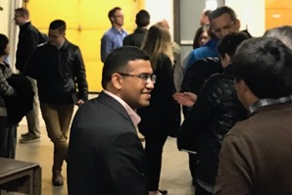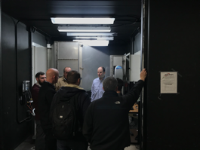
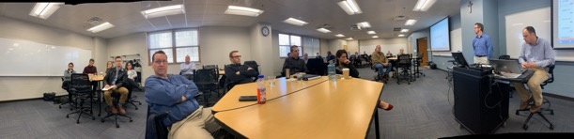
Figure 10.5 I organized the 2018 and 2019 Spray Drift Seminar at the University of Dayton

Faculty Self-Evaluation:
Accomplished
Comments:
I have served as a director of wind tunnel, water tunnel and the flight simulator for many years accommodating, scheduling, and planning several teaching, research, and outreach activities in the three labs. I have hosted Air Camp students for several years and organized booths in different events around Dayton with the aim of inspiring the next generation of students to join aerospace engineering. I have served the Kern Family Foundation in multiple roles such as community catalyst, subnet catalyst, and recently, I was selected to be a member of the KEEN National Conference (KNC) planning committee and coaching the workshop presenters. I am also selected to lead the 2023 AIAA Region III student conference at the University of Dayton in March 2023. For these reasons, I self-evaluate myself as accomplished in service.
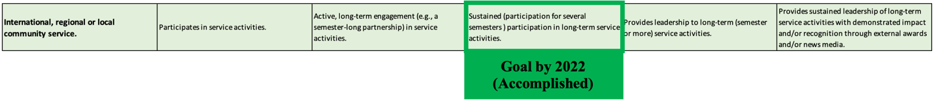
Department Faculty Development Committee Assessment (To be completed ONLY when the faculty member is going up for midterm or tenure and/or promotion review)
Choose an item.
Comments (optional):

Department Chair Assessment:
Choose an item.
Comments (optional):

School of Engineering Faculty Development Committee (To be completed ONLY when the faculty member is going up for midterm or tenure and/or promotion review)
Choose an item.
Comments (optional):

Associate Dean for Faculty and Staff Development:
Choose an item.
Comments (optional):

Summative Comments:
Faculty Member: Provide a self-evaluation of your overall progress at meeting the goals of your Professional Strategic Plan. Indicate any factors that have impeded your progress during the evaluation period. For annual performance review or first comprehensive periodic review, summarize your approach to make progress on your Professional Strategic Plan.
Faculty Member:
Since 2016 I have made significant progress towards teaching, research, and service as evidenced in this document. I taught a total of 9 different courses with several documented evidence of employing modern pedagogical practices, techniques, and strategies, some of which have been published in national magazines (KEENzine and Aerospace America). Despite not being a US citizen, in the field of aerospace engineering, I managed to bring in funding from government organizations, foundations, and industry most notably from DAGSI, DARPA, and BASF. I mentored several undergraduate and graduate students’ thesis and projects and made conscious effort to attract female students and underrepresented groups towards aerospace research. As a director of UD low speed wind tunnel, I got the wind tunnel certified by EPA to perform drift reduction technology type testing and as a director of UD Water Tunnel, I managed to get DAGSI funding and on-going support from AFRL. I also continue to find student technicians to run the flight simulator and coordinate activities and outreach events. I have also created an inclusive research community in my labs where students feel a sense of belonging that they add value to the group even after graduating. With students, I have published over 30 conference papers in peer-reviewed conference since 2016, 7 peer reviewed journals, and 3 ASEE papers. I have served the department and the university by being a member of faculty search committee, and the DEI strategic planning committee. I was also selected to an advocate for the UD Men for Gender Equity Initiative in the school of engineering. I advise three student clubs and have organized several competitions, dinner meetings, and outreach events to inspire and educate the next generation of students. I am also selected to be in the 2023 KEEN National Committee and workshop coach and lead the 2023 AIAA Region III Student conference to be hosted at UD in March 2023. For these reasons I evaluate myself as accomplished overall.

Signature: Sidaard Gunasekaran Date: 06/30/2022

Department Faculty Development Committee: Please provide summative comments regarding the faculty member’s progress on their Professional Strategic Plan and their approach for the next calendar year.

THE FACULTY MEMBER IS MAKING SATISFACTORY PROGRESS TOWARDS TENURE AND/OR PROMOTION: ☐ YES ☐ NO

Signature: Date:
Signature: Date:
Signature: Date:

Department Chair: Please provide summative comments regarding the faculty member’s progress on their Professional Strategic Plan and their approach for the next evaluation period.

THE FACULTY MEMBER IS MAKING SATISFACTORY PROGRESS TOWARDS TENURE AND/OR PROMOTION: ☐ YES ☐ NO

Signature: Date:

School Faculty Development Committee (for first comprehensive review, and promotion and tenure review only): Please provide summative comments regarding the faculty member’s progress on their Professional Strategic Plan. For the First Comprehensive Review, also provide feedback on the faculty member’s plan for making progress on their PSP.

THE FACULTY MEMBER IS MAKING SATISFACTORY PROGRESS TOWARDS TENURE AND/OR PROMOTION: ☐ YES ☐ NO

Signature: Date:
Signature: Date:
Signature: Date:
Signature: Date:
Signature: Date:
Signature: Date:
Signature: Date:
Signature: Date:
Signature: Date:

Associate Dean for Faculty and Staff Development: Please provide summative comments regarding the faculty member’s progress on their Professional Strategic Plan and their approach for the next calendar year.

THE FACULTY MEMBER IS MAKING SATISFACTORY PROGRESS TOWARDS TENURE AND/OR PROMOTION: ☐ YES ☐ NO

Signature: Date:

Collis, K.F. and Biggs, J. (1986). “Using the SOLO taxonomy”. Set: Research Information for Teachers, 2(4).

